  - RAMP Registration Platform
Step A: Create a New Account
At the Login Screen, scroll to ‘Don’t have an account? Create one Here’
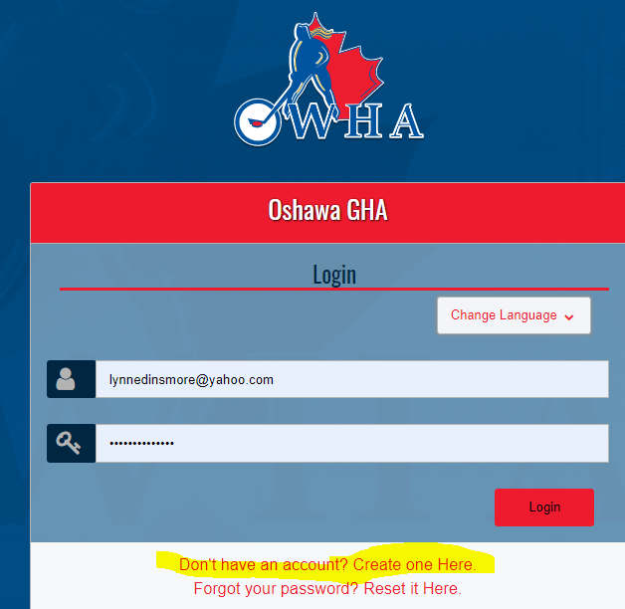

Step B: Fill in the pertinent information. Remember your password, as you can log into your account throughout the year to review your registrations, members you have registered, payments made, and our refund policy.
Once completed, click on ‘Click here to Go Back to Login Page’
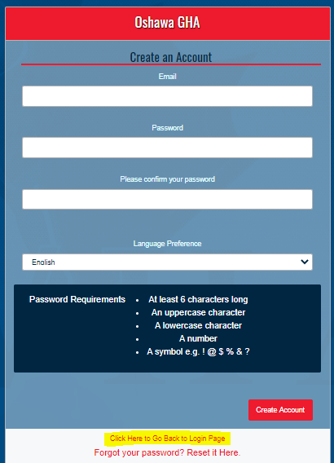
Step C: Register as a Participant. Click on the Participant image to continue through the registration.
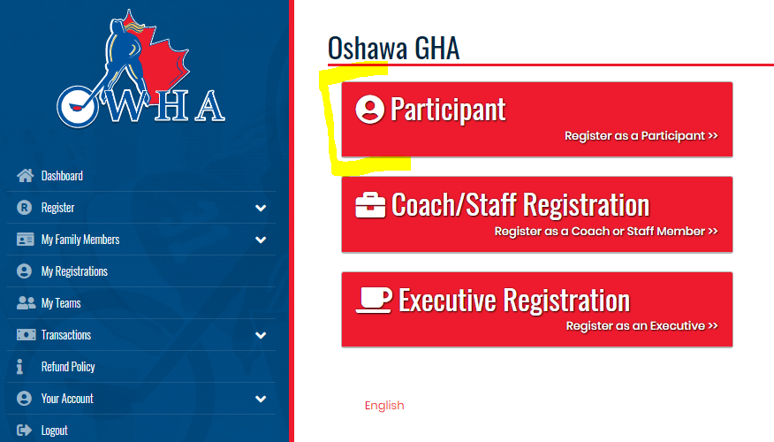
Step D: Fill in your Participant Information:
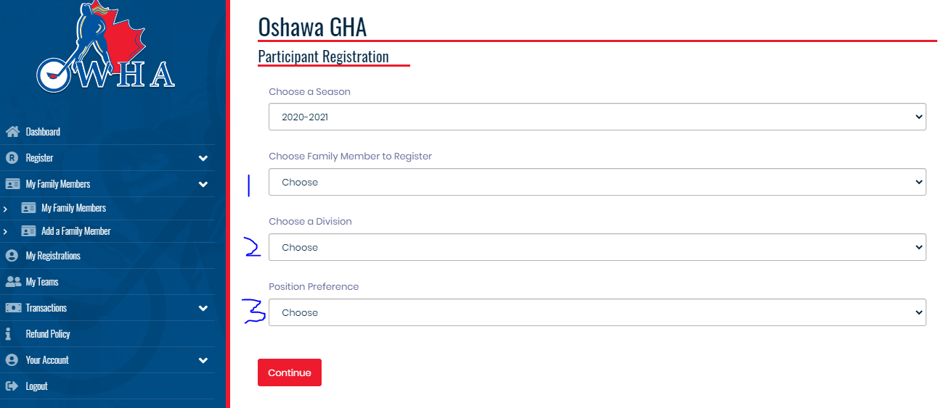
- Choose Family Member to Register (Image 1 on Page 6). In Step A&B you only created an account, so at this step you have to choose, Add a Family Member from the drop-down menu. NOTE: If you are signing other people in, you can also Add them as a Family Member, HOWEVER, this person will have to access your account to review any information about themselves. So, it is best where possible that registrants create their own accounts.
- Choose a Division (Image 2 on Page 7).
The choices will be:
  - Senior HL Over 19 (THIS IS THE REC DIVISION)
  - Senior HL Compt Over 19 (THIS IS THE OPEN DIVISION)
SORRY, the Division Names were created by the OWHA, hope it is not confusing!
When you Pick your Division, a Package Screen will present itself under Step 3, Position Preference. (See image 4 on the next pages). At this point, you should see whether you have chosen the right division, as per the Package Titles. If you have picked the wrong division, you can update that now.

NOTE: If you are registering for more than one division (Goalie in one, Player in another, you will have to log back into your account to go through these steps again.

- Position Preference (Image 3 on Page 7). The choices are Player or Goalie, and this is for the OWHA database information. More information regarding League Questions will follow.
NOTE: As you fill in each section, the ENTIRE choices populate and are shown on a continuous page, as you go through each of the three steps. It does look busy, but if you forget to fill something out, you will get a reminder message.

Step E: Choose your Registration Package, this is league specific.
In this example below, the Division chosen was Senior Over 19, therefore the packages for Rec appears. Choose either Player or Goalie. As payments are not going to be collected until we are positive of the season start, some arbitrary dates and amounts have been noted. This might be adjusted, prorated, once further information is obtained from the OWHA.
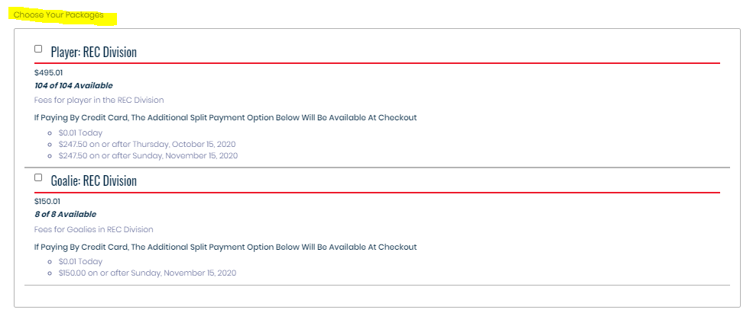
Click on this once you have picked the Package.
Continue
Package names are specific to the Division chosen and are:
- Player: REC Division
- Goalie: REC Division
- Player: OPEN Division
- Goalie: OPEN Division
Step F: WAIVERS
There are four waivers that will populate, and each will have a signature box below. Read the waivers, and sign. The registration process will not continue until a signature is noted. Sign, or initial, as best as possible. NOTE: These are OWHA Mandatory Waivers, with exception of the Refund Waiver, and by continuing through to the end of the registration process, it will be noted by whatever signature you have provided, that you are in agreement with the policies noted. These waivers will appear on your Registration Confirmation.
Examples of the Waiver/Signature:
You have the option on this one, to either check the Photo Download or Not. This is the OWHA asking, not the league  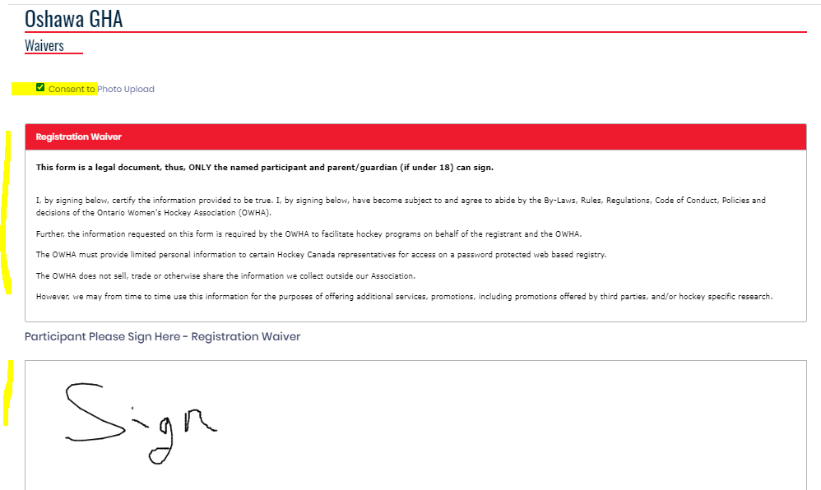 | The Parent/Guardian Waiver is a little confusing, as you have to sign as well as click on that you are Age of Majority.  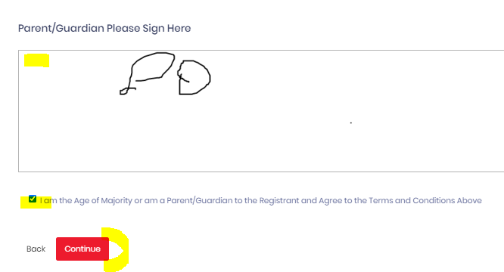
Step G: Uploads
This is an optional choice to upload a birth certificate. If we require one, we will reach out to individuals to obtain.
Click on Continue to carry on to Step H
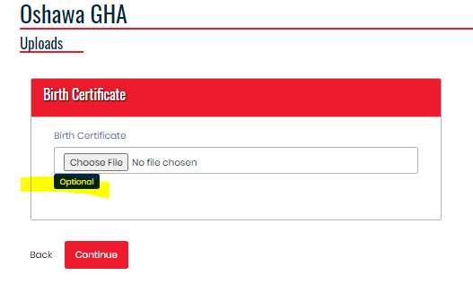
Step H: The Package Questions
- Questions 1 to 6 will appear if a Player Package was chosen
- Questions 3 to 6 will appear if a Goalie Package was chosen
- Fill in your appropriate answers

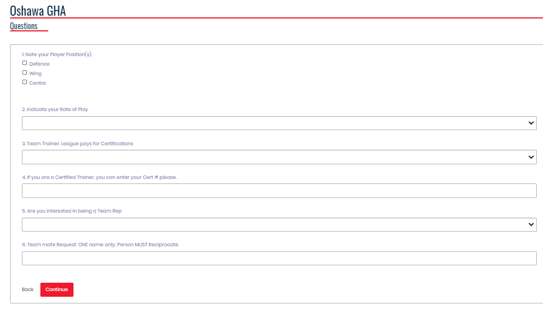
After clicking on Continue, you will receive a Confirmation Message, noted on the next page, followed by an email.
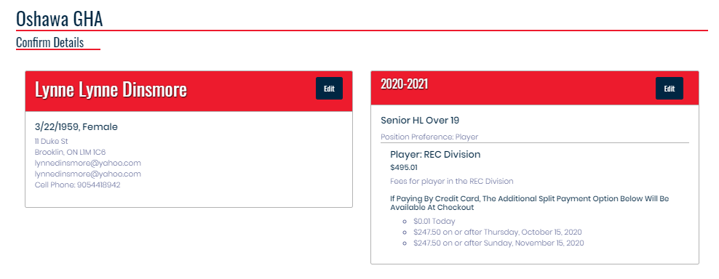
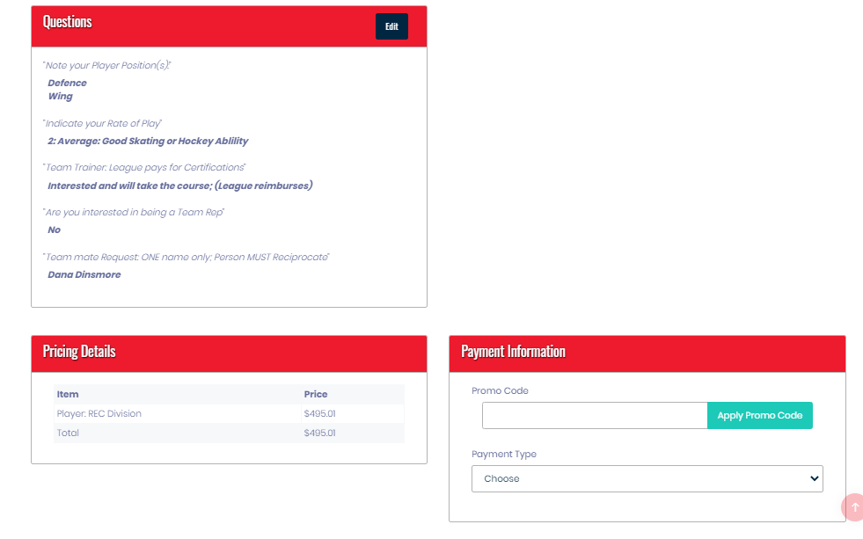
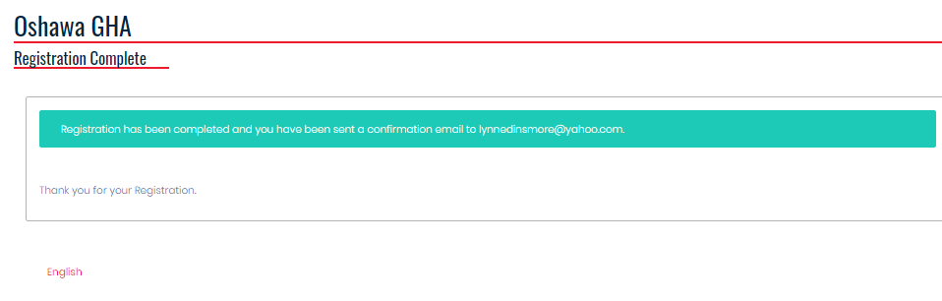

Images of the 3 choices noted for Participant Information. Upon picking your Division, you will see the packages available for that Division.
Image 1: Add a Family Member. HCRID is your Hockey Canada Registered ID, if you know it enter, but if not leave it blank.
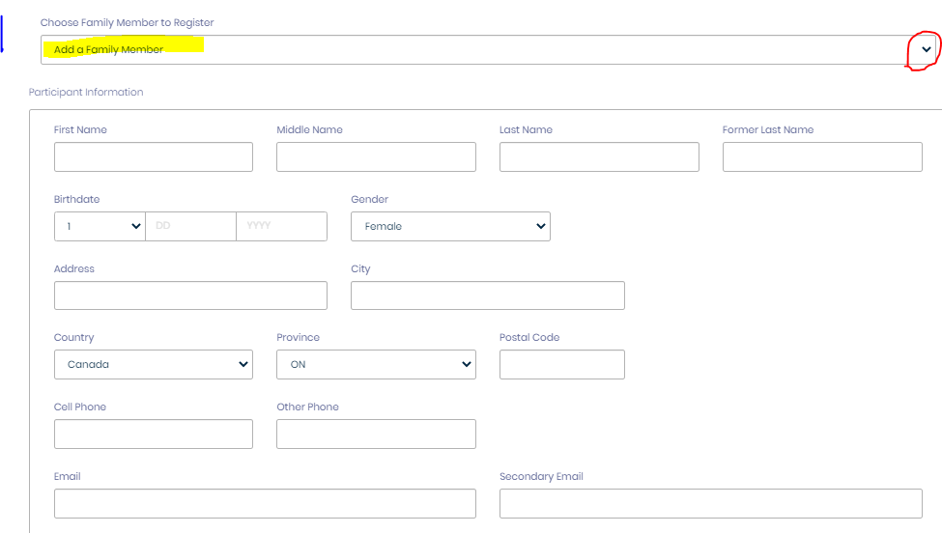
IF the fields below are shown, YOU MAY IGNORE. But if you know any of the cert numbers required below, you may fill it in.
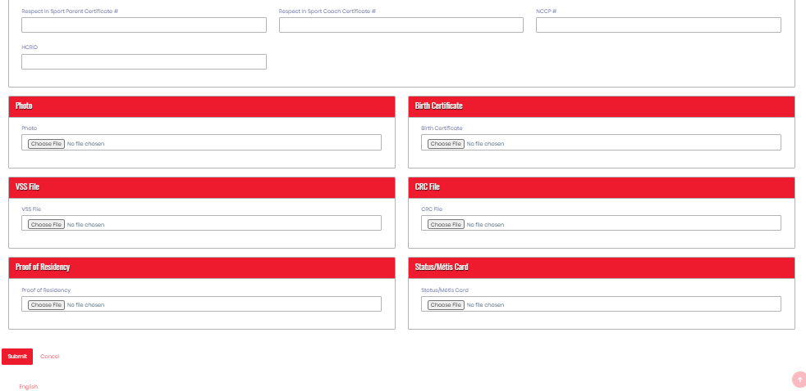

Image 2: Choose a Division
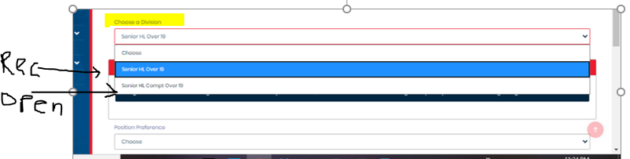
Image 3: Position Preference
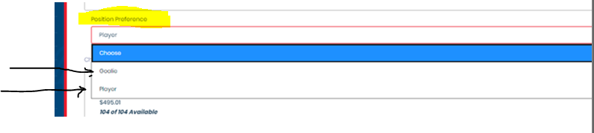
Image 4 (The Division Package, which leads into Step 5)

