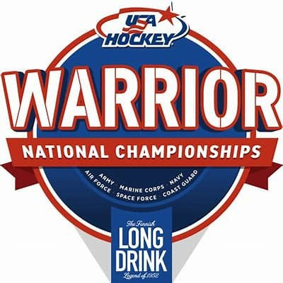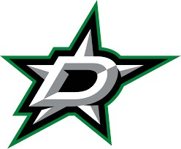
2026 USA Hockey–Long Drink Warrior National Championships

Things to Do & Special Events Guide

Things to Do While You’re Here
- Public skating at other StarCenters across the Metroplex
- The Star in Frisco and AT&T Stadium Tours
- PGA of America Headquarters (Frisco)
- Fort Worth Stockyards
- COSM – The Colony
- Top Golf – Dallas, Allen, The Colony
- Perot Museum of Nature & Science

Dallas Stars Watch Party
Little Woodrow’s – Frisco
8320 State Highway 121, Frisco, TX 75034 April 22 & April 25 | 8:30 PM

Top DFW BBQ Spots
- Hutchins BBQ (Frisco / McKinney)
- Hard Eight BBQ (Coppell / The Colony)
- Terry Black’s Barbecue (Dallas)
- Pecan Lodge (Dallas – Deep Ellum)
- Tender BBQ (Frisco)
- Heim Barbecue (Fort Worth)

Food, Drinks & Nightlife
- Moxies – Frisco, Dallas
- Shark Club Sports Bar & Grill – Frisco

Entertainment
- Legacy West - Frisco
- Grandscape – The Colony
- The Galleria
- North Park Mall
- Movie Theaters (Alamo Drafthouse, Cinemark,
- Bowling and Arcade Venues (Main Event, Pinstack)

Special Playoff Opportunity for Championship Participants
Participants and families are invited to attend Round 1 of the ECHL Kelly Cup Playoffs at CUTX Event Center in Allen, Texas.

Premium and Suite Tickets are discounted to $40 from $70

Allen Americans vs. Idaho Steelheads
Thursday, April 23 & Friday, April 24 | Puck Drop: 7:00 PM | Doors Open: 6:00 PM Reference ‘Warrior Nationals Offer’ when emailing ticket representatives.

Randell Holmes
RHolmes@CUTXEventCenter.com
Mike Martin
Mmartin@CUTXEventCenter.com

