Team Ontario Baseball adds Alumni Palmer Cruikshank to 16U Coaching Staff.
Team Ontario Baseball is excited to announce the 2017 Team Ontario grad, OCAA National Champion and OBA Jr AAA national champion Palmer Cruikshank. He has accepted the opportunity to join the 16u coaching staff. Palmer's responsibility will include working with corner infielders while assisting coach Ringwald with the team's catchers and hitters
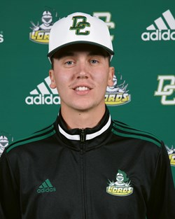
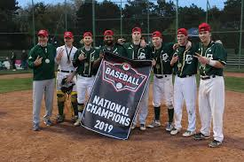
Palmer is a class of "2017 Team ON Grad, who was the inaugural co-winner of the Murray Marshall Scholarship Award and is a graduate of Ellsworth Community College, Juco D2, in Iowa. Currently, he is a member of the Durham College Men's OCAA National Championship baseball team, as well as a member of the Oshawa Legionnaire Jr. National Championship team for '2019.

As a catcher/first baseman, Palmer brings a wealth of experience and knowledge of each position. Golden Glove Recipient of the '2019 OCAA Men's National Baseball Championships as well as expertise of being part of a team that has overcome adversity to win.
Palmer grew up playing for the Oshawa Legionnaires, where he has won several tournament awards, league MVP awards, as well as being a member of the EOBA Gold Medal Summer Games team in '2014, before taking his game to the next level by joining Team Ontario Baseball.

When asked how it feels to be returning to Team O now as a coach,
"I look forward to returning to the Team Ontario Astros organization to share my knowledge and experiences to date."
