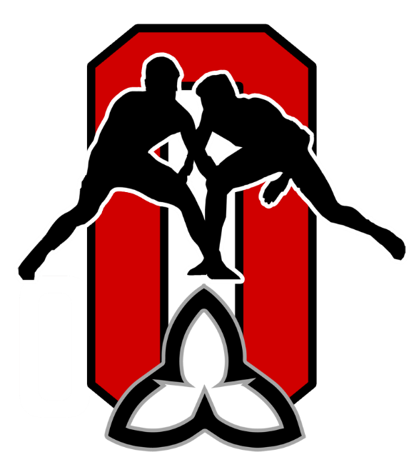
OAWA March 2020 Coaches’ Mailing

Coaching Course Upcoming:
The Hamilton Wrestling Club is hosting a NCCP multi-sport module, that is one of the modules required for the NCCP Competition Development certification.
Course Offered: Developing Athletic Abilities
Date: Sunday, March 22, 2020
Time: 9am - 5:30pm
Location: 1824 Rymal Rd E,
Hannon, ON L0R 1P0
More Information:
http://www.coachesontario.ca/events/hamilton-daa/
Reminder: Check the Coaches' Ontario Site regularly for availability of Coaching Courses near you, courses available on-line and so on.

LAST Call for Respect in Sport Training!
The OAWA will be shutting down the access for the Respect in Sport Training for OAWA Coaches. If you haven't completed your training, do so right away or you will have to pay for the course.
Go to this LINK on the OAWA web site to view the Safe Sport Training and information again.

2020 Junior and Senior National Championships Reminders
Date: MARCH 27-29, 2020
Location: Western Fairgrounds Agriplex
– Show Arena. London, ON
Event Brochure: Get it HERE
Clubs/Coaches are reminded that for the 2020 National Junior and Senior Championships, all clubs are responsible for making all their own travel, accommodation and entry arrangements. Clubs are also reminded that under WCL’s Policy Clubs are responsible for all their own ground transportation for the Junior and Senior Nationals.
For 2020 there will be an OAWA Athlete Sanction fee:
$100.00 per athlete (payable to London-Western WC)
The Sanction fee is to assist the host club with event hosting expenses.
Go to WCL Registration and other information:

WCL REGISTRATION LINK

All athlete and support staff (coaches, team leaders, medical and officials) registrations and payments, where applicable, must be made online through the links above.

The early registration deadline has already passed. Late registrations will be accepted until March 20th, 2020 at 11:59 pm ET, but will be subject to a late fee as outlined in the “Entry Fees” section of the event brochure. No registrations will be accepted after March 20th, 2020 at 11:59 pm ET. This applies to all athletes, coaches and support staff.
CLUBS ARE RESPONSIBLE FOR REGISTERING THEIR ATHLETES, COACHES AND SUPPORT STAFF
All athletes, coaches and support staff must be registered members in good standing with the OAWA as well as Wrestling Canada Lutte.

2020 National U-17/U-19 Championships Reminders:
Click the links to find out more information on the following:
Sorry, the deadline has passed for ordering Team Ontario gear.
2020 National U17/U19 TEAM ONT-Trip Info package
2020 Information for Clubs Traveling Independently to U17 & U19 Nationals

Ontario Youth Wrestling Festival

Saturday April 25, 2020
Rotary Place, Orillia
Get the Tournament Flyer HERE

Canada East Youth Festival
May 8-10
Halifax, Nova Scotia
www.wrestlingns.ca
Register Site Link: https://wrestlingns.ca/tournament-registrations

2020 OAWA Annual General Meeting

Saturday June 6, 2020
David Suzuki Secondary School
45 Daviselm Drive, Brampton, ON
Items expected to be on the AGM Agenda include the following:

- Constitutional Amendment
At this year’s AGM, the following motion to amend the OAWA Constitution will be tabled:
MOTION: “That the OAWA adopt the new by-Laws for the Association”.

- Notice of Executive Committee Elections:

The following positions will be up for election at this year’s AGM (subject to change based on the new by-Laws:
VP Administration, Secretary, Treasurer
More information to follow and watch for regular updates on the OAWA web site.

