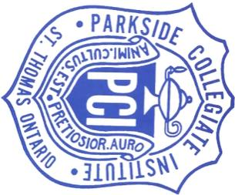
Parkside Wrestling Tournament 2025

ELIGIBILITY: Novice(gr 9/10 or first year) and Open
Co-Sanctioned with OAWA

LOCATION: Parkside C.I. 241 Sunset Dr. St, Thomas Ontario, N5R 3C2
Gym. The back door near the portable/football field will be open.

DATE: Saturday December 6th , 2025. Wrestling begins at 9am

COST: $25 per athlete. Receipts will be given out at the tournament

FORMAT: 4-5 mats, OFSAA Rules

WEIGHT CLASSES:
MALE: 38, 41, 44, 47.5, 51, 54, 57.5, 61, 64, 67.5, 72, 77, 83, 89, 95, 130, OVER 130
FEMALE: 38, 41, 44, 47.5, 51, 54, 57.5, 61, 64, 67.5, 72, 77, 83, 89, 95, 115, OVER 115
*red dot - weigh in between 8-8:30*

REGISTRATION: submit using the excel file provide to Alicia Rowlands (a.rowlands@tvdsb.ca) by 6pm Thursday, December 4th.

If you have any questions call or text

Alicia Rowlands - 519-871-4726
Adam Dale - 519-670-9345
Paul Cumberland – 226-448-4906

