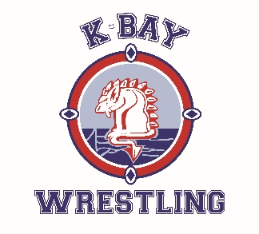
K-BAY OPEN

NEW Date: Saturday January 10, 2026

NEW Location: St. Joan of Arc Secondary School
460 Mapleton Ave, Barrie, ON L4N 9C2
Registration: All Entries must be submitted to the drawmaster -
Ashley Menagh (wrestlingentries@gmail.com)
by 8pm Tuesday January 6, 2026.
Please use the attached excel document to place weights and genders and age classes
Weight/Age Classes:
- High School Men/Women (2008-2011); by weight class and gender below;
Boys: 38, 41, 44, 47.5, 51, 54, 57.5, 61, 64, 67.5, 72, 77, 83, 89, 95 kg, 130, 130+kg. Plus 1 kg.
Girls: 38, 41, 44, 47.5, 51, 54, 57.5, 61, 64, 67.5, 72, 77, 83, 89, 95, 115, 115+kg. Plus 1 kg.
- Rookie High School Men/Women (2008-2011) – by weight class and gender below (however if not enough competitors per weight class, they will grouped with closest weight class or moved to the experienced group):
Boys: 38, 41, 44, 47.5, 51, 54, 57.5, 61, 64, 67.5, 72, 77, 83, 89, 95 kg, 130, 130+kg. Plus 1 kg.
Girls: 38, 41, 44, 47.5, 51, 54, 57.5, 61, 64, 67.5, 72, 77, 83, 89, 95, 115, 115+kg. Plus 1 kg.
- Bantam Boy/Girl (2012-2013) - Group by weight/gender, 1 kg variance
- Kid Boy/Girl (2014-2015) - Group by weight/gender, 1 kg variance
- Novice Boy/Girl (2016-2017) – Group by weight/gender, 1 kg variance

The Drawmaster will make every effort to group athletes in their respective divisions; The drawmaster will connect with any coaches about moving divisions; and will let coaches know about any athletes that do not have matches.

Weigh In: 8:00 am Red Dot Coaches Meeting: 8:30 am
Wrestling Starts: 9:00 am.
Awards: Medals for top 3
Mats: 6 Mat surfaces
Entry Fee: $35 per wrestler (Please make cheques payable to Kempenfelt Bay Athletic Club)

NO SPECTATOR FEE BUT THERE WILL BE A GREAT SILENT RAFFLE TO ENTER FOR GREAT PRIZES!!!

This is a co-sanctioned event with the OAWA and OFSAA. Please ensure all club coaches are OAWA members, or members in good standing with a Wrestling Canada affiliated PTSO in order to be given a coach’s wristband. All secondary school coaches must be registered, as well as senior athletes acting as coaches to be given a coach’s wristband.

