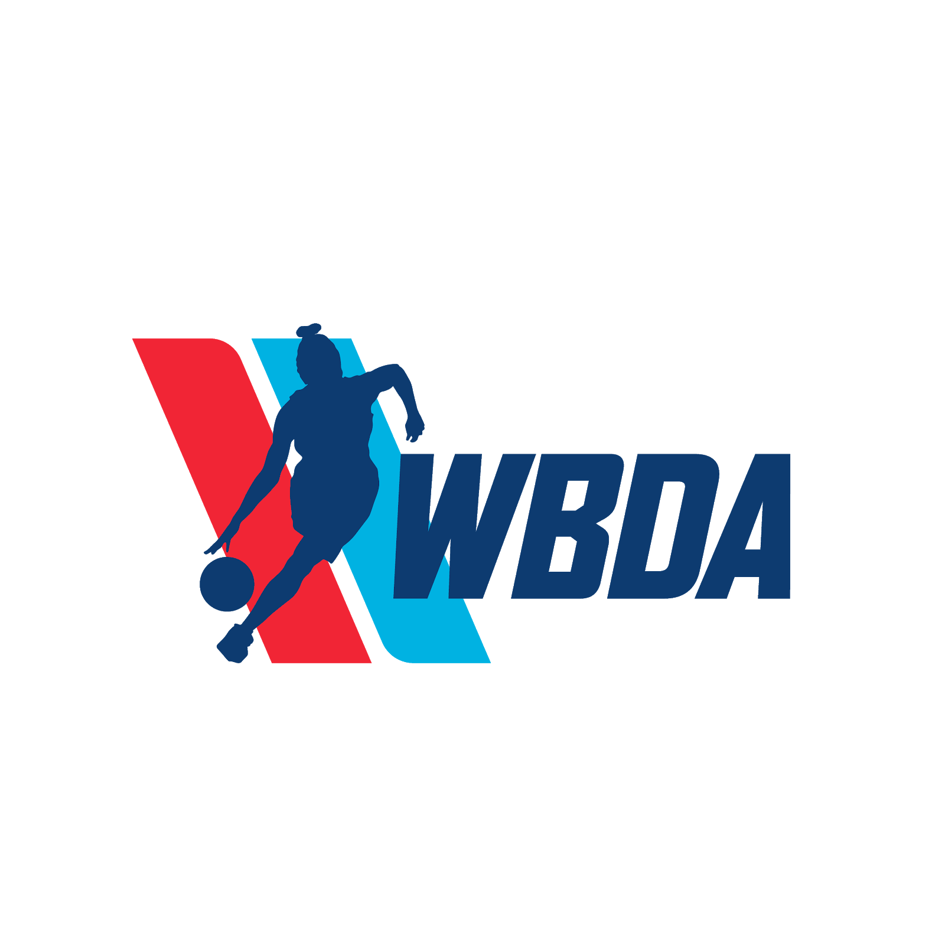

League News & Updates

Hello,
The Women’s Basketball Development Association has been monitoring the current COVID-19 pandemic very closely in efforts to protect all our members and communities. We first would like to mention how the safety and health of people are our top priority during this difficult time. With the WBDA being a global organization with players stationed in countries around the world during their professional seasons abroad, we have been focusing on making sure everyone can get home safely. Secondly, with the recent news on the closure of the Canadian border and most foreign travel, WBDA Canada, WBDA Mexico and our Hawaiian region are affected as well. The U.S. government has issued a suggested max gathering of 10 people for the next 15 days, so we are cancelling all Tryouts, Combines and Preseason events until further notice.
We have several plans established to be able to continue our 2020 season, however we have not decided on which plan we will follow at this time. With our season scheduled to begin May 2nd, we will be sharing our plans very soon. As more information becomes available regarding the next steps on the COVID-19 pandemic, we will keep everyone updated on our 2020 season plans.
The WBDA wishes all team owners, staff, players, partners, fans and the general public safe keeping and health.

William Kelly
WBDA CEO

