2026-2027


SELECT YOUR SEAT AND SAVE 25%!
PRICE LEVEL | # OF TICKETS | GAME DAY PRICING | EARLY BUY PRICING | SEASON TICKET PRICING
P1 |  | $28 | $26 | $588 - $196 Savings! ($21.00 per game)
P2 |  | $26 | $24 | $546 - $182 Savings! ($19.50 per game)
P3 |  | $21 | $19 | $483 - $105 Savings! ($17.25 per game)
P4 |  | $19 | $17 | $429 - $103 Savings! ($15.25 per game)
 |  |  |  | TOTAL:

PAYMENT INFORMATION
CASH | CARD | CHECK
CARD NUMBER
EXP DATE CVV
ZIP CODE
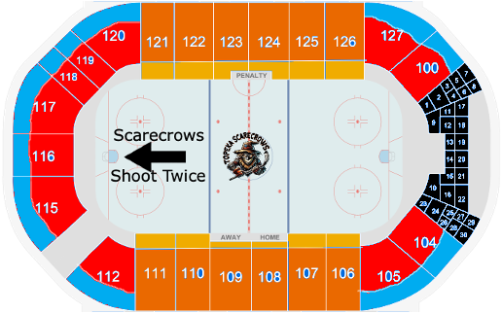

Reserve Your Seat Today!
With Just $50 Non-Refundable Deposit Per Seat

NAME
ADDRESS
CITY | STATE |  | ZIP
PHONE |  | EMAIL

Option 1 – 50% Paid June 1st 2026 and final 50% due on September 1st, 2026
Option 2 – Pay in Full June 1st 2026
Questions? Contact the Scarecrows 785-289-4259 or email TopekaScarecrowsFPHL@gmail.com
Section: _________ Row: ________ Seat #(s):_______________________

