DOWNLOAD THE APP FOR YOUR TEAM(S)!

Go to APP store
Type in HockeyShift

Download the app
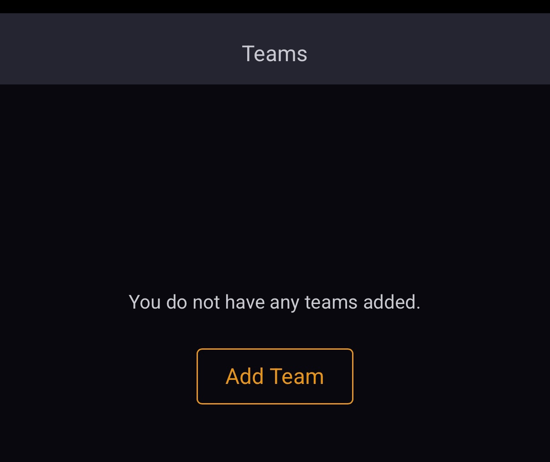
Click add team
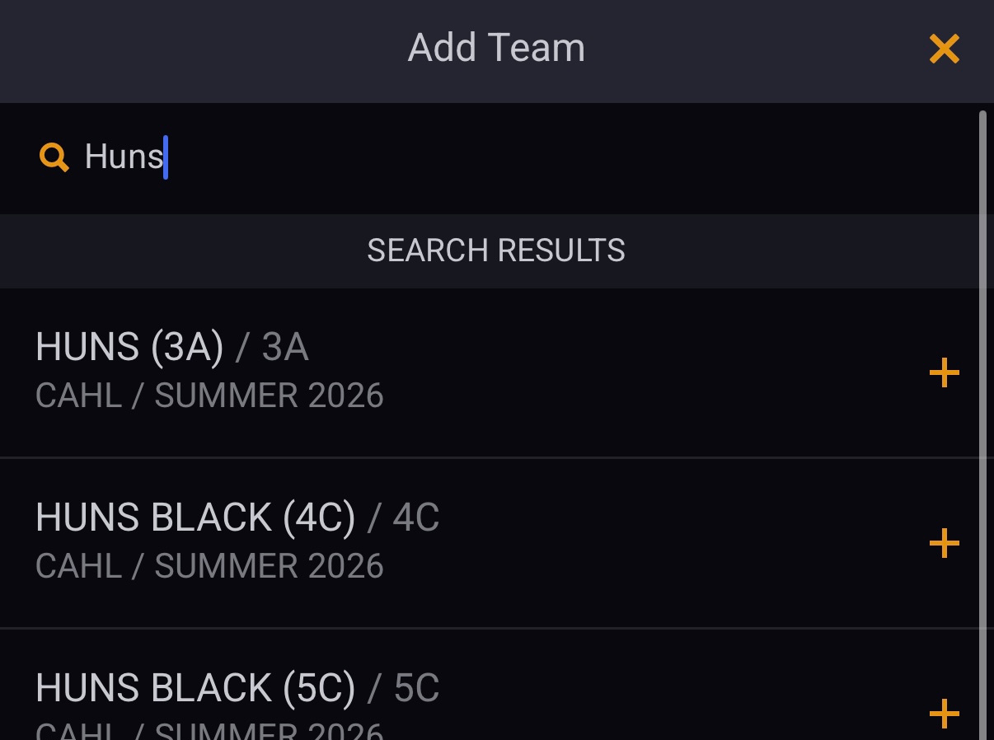
Type in your team name and find the team and division you want to add (you can add as many as you want!)
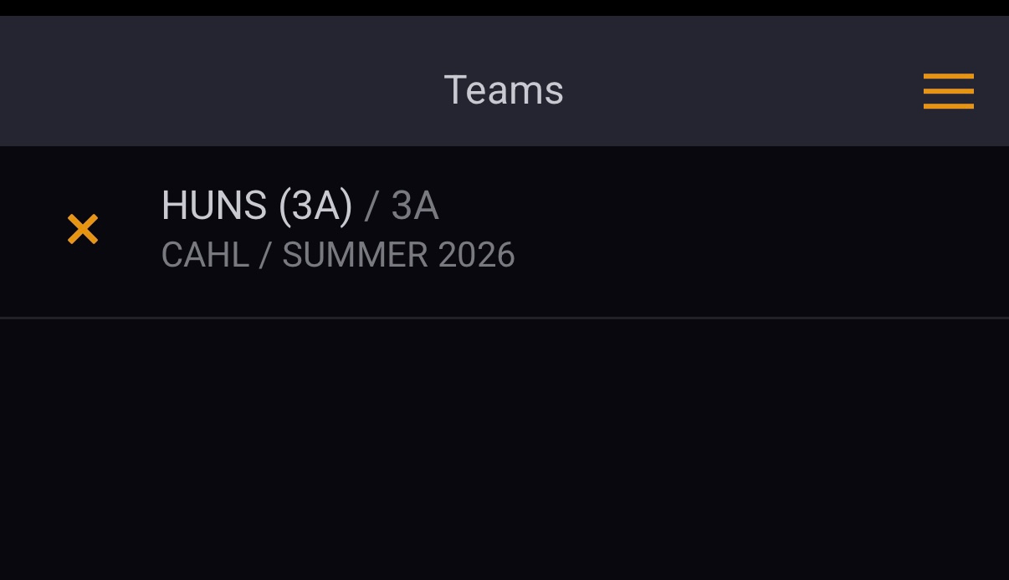
Click the 3 yellow lines in the top right corner
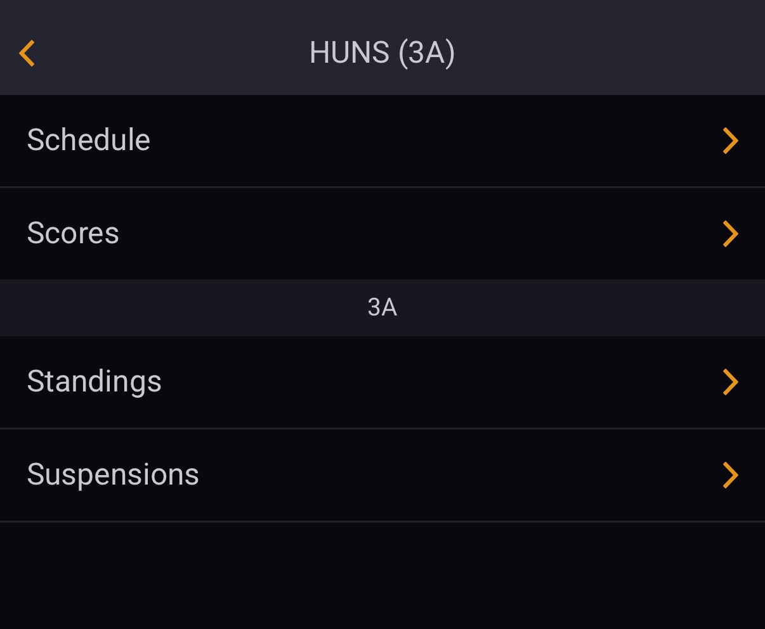
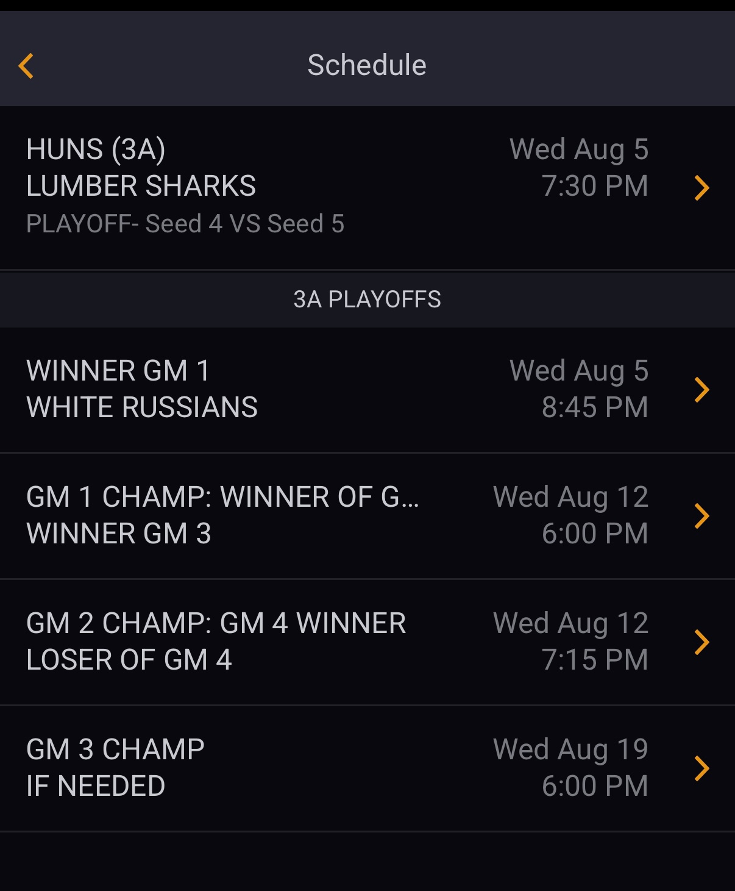
View your schedule, score, and standings!

