ACCESS TEAM PAGE FOR SCORES AND REMAINING GAMES

FOR DESKTOP:

Click CAHL SCHEDULE/STANDINGS
Click STANDINGS
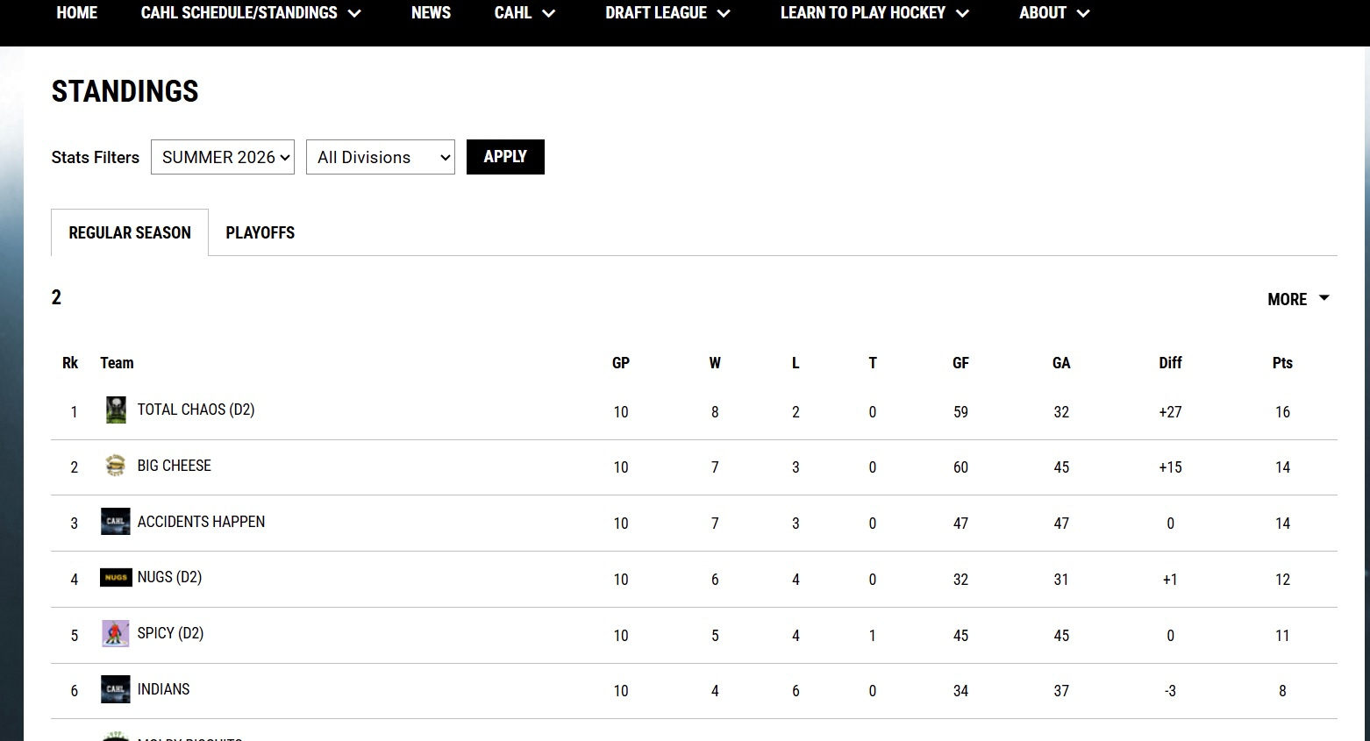
Scroll to your division and click your team
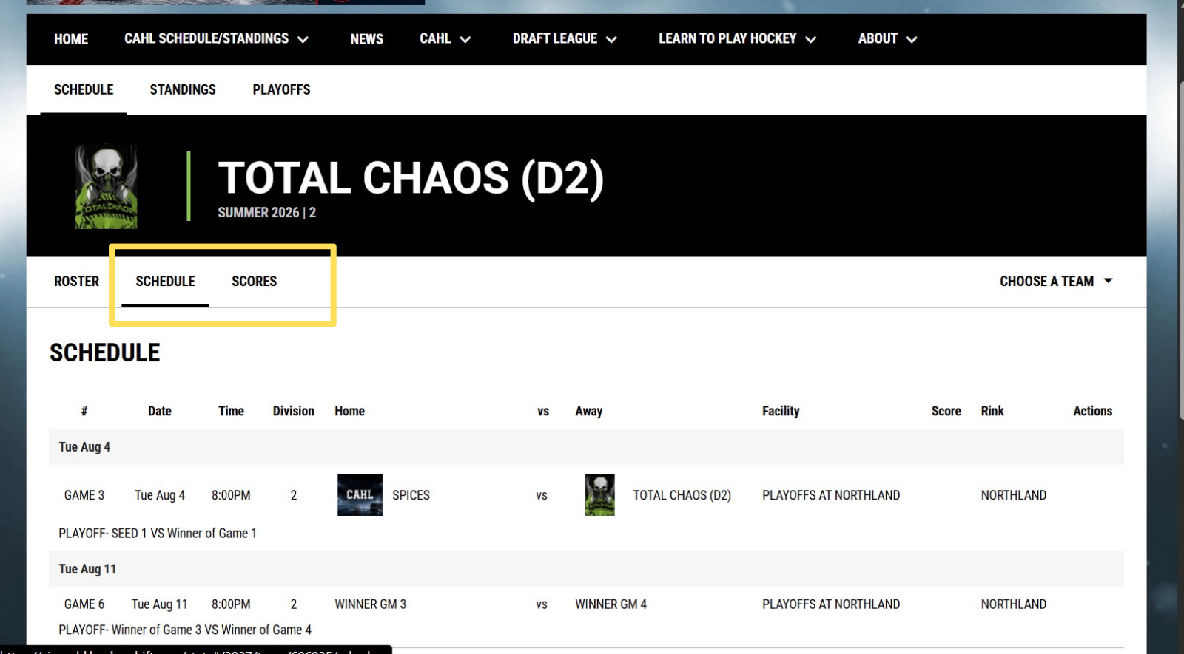
Click schedule or scores to view remaining schedule or season’s scores
FOR MOBILE:

Click the 3 bars on the top right
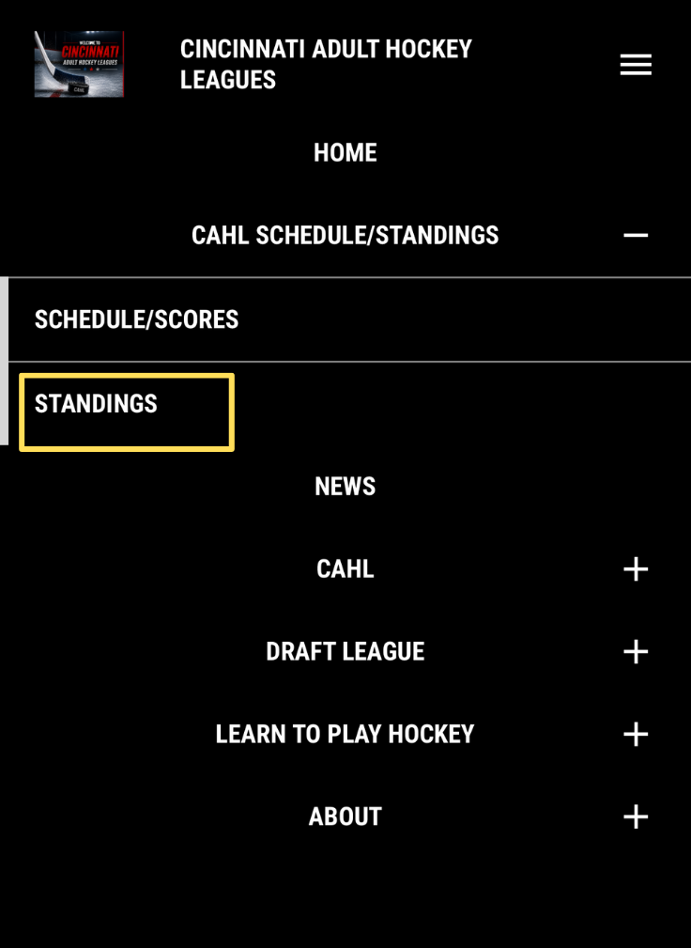
Click CAHL SCHEDULE/STANDINGS
Click STANDINGS
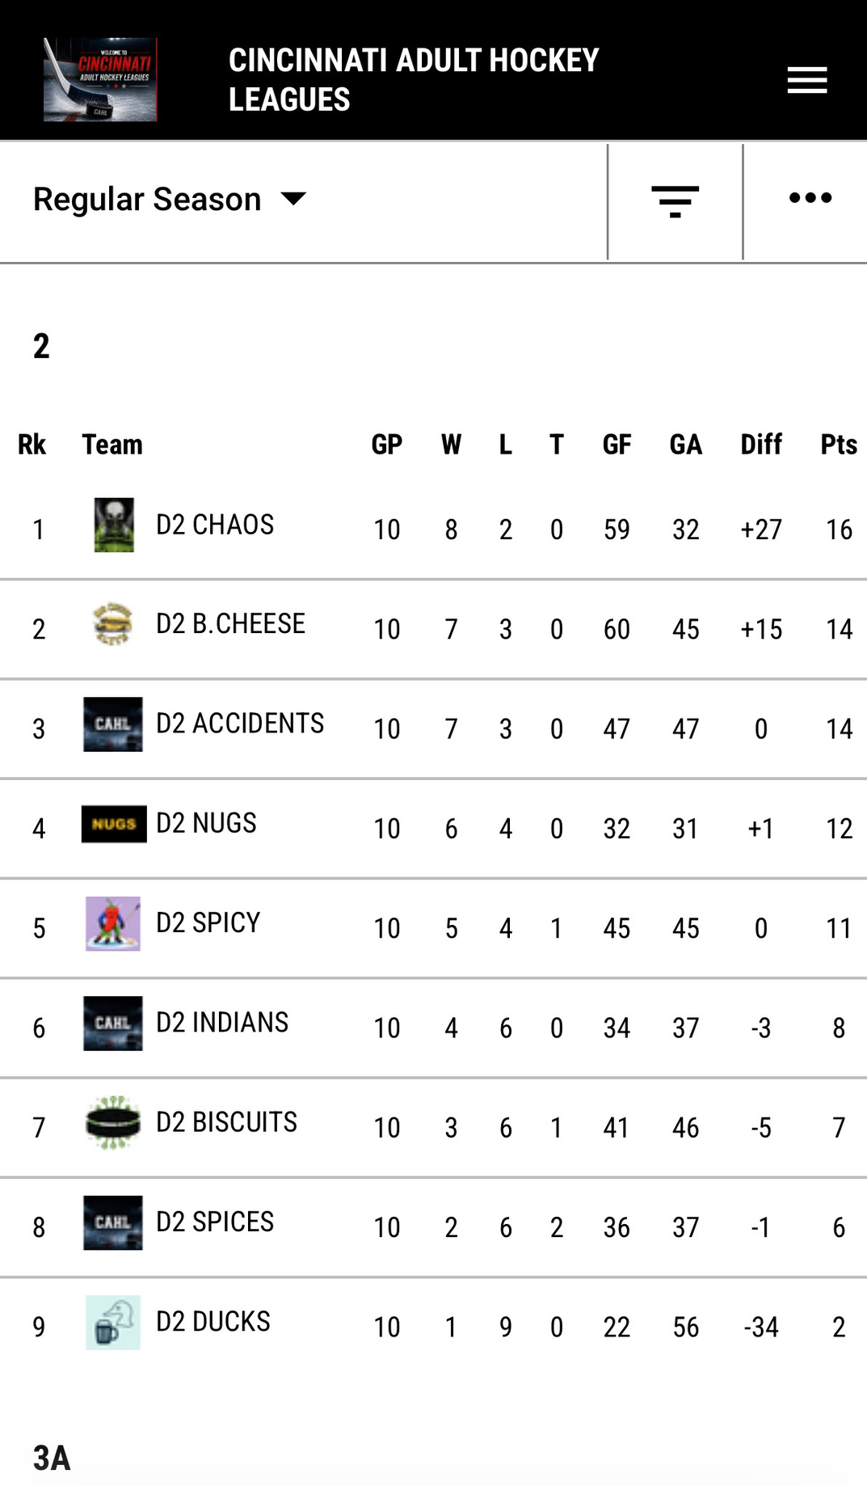
Scroll to find your team
Click your team
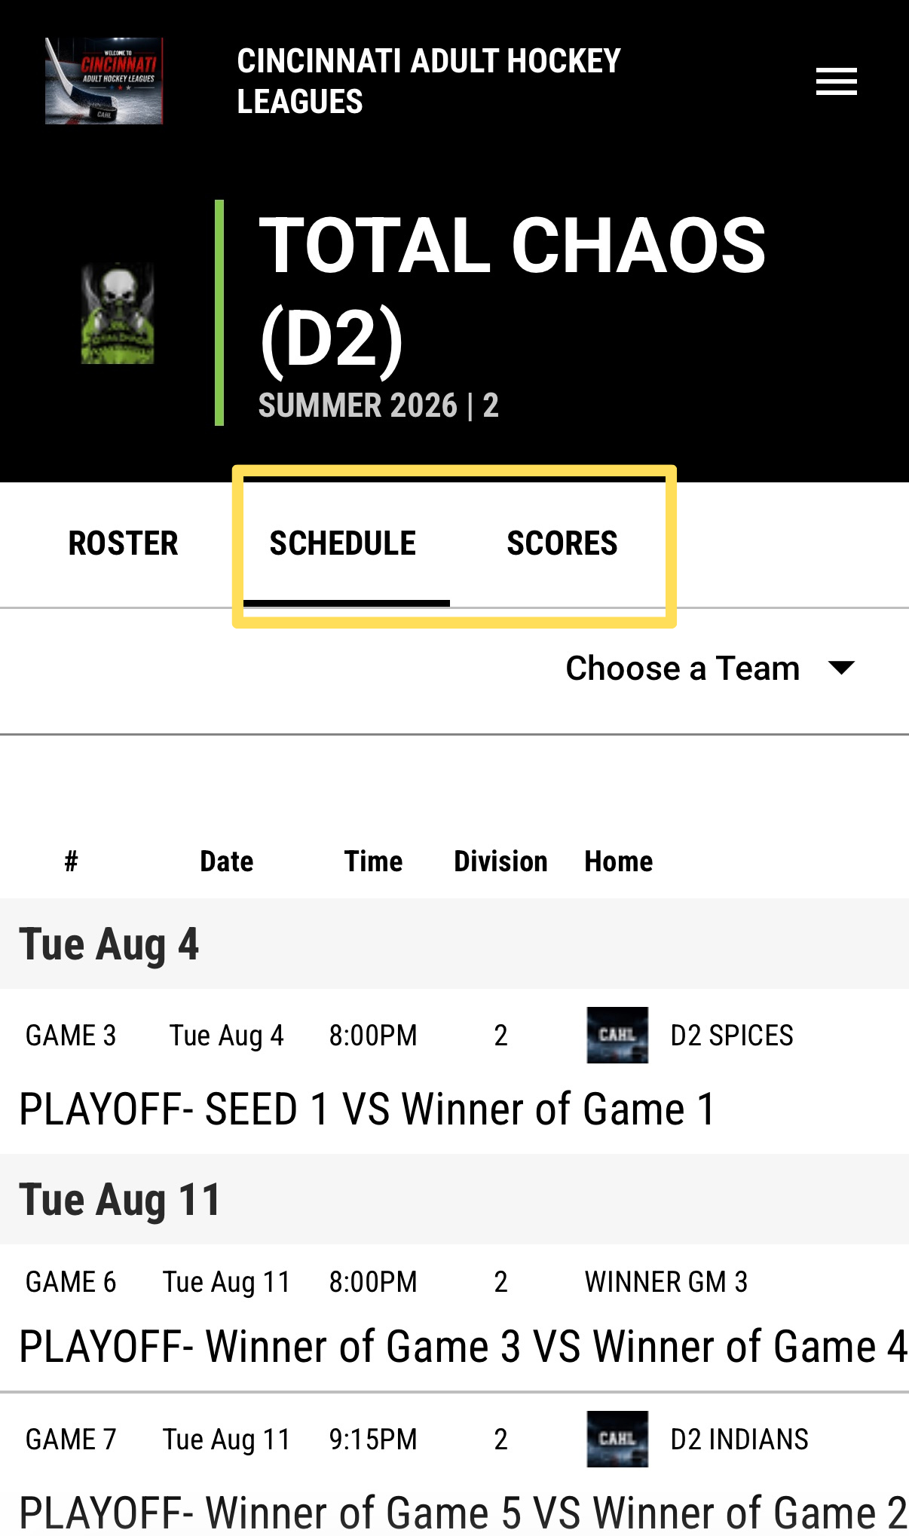
Click SCHEDULE or SCORES to access.

