ACCESS CURRENT AND FULL SCHEDULE
** Team schedules can be bookmarked on browsers and phones for quick access!
** Please note that this is for the full season, current schedule will show remaining games only! Click CURRENT SCHEDULE or FULL SCHEDULE to change
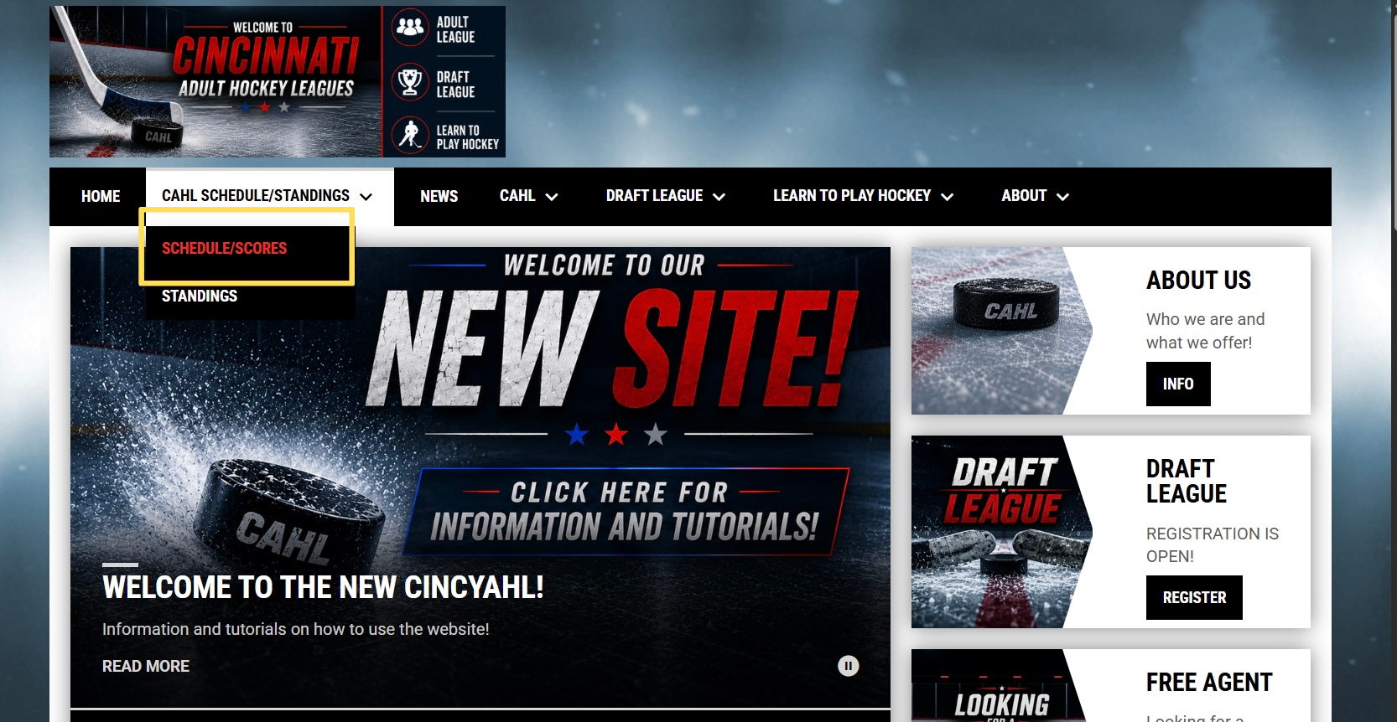
Click CAHL SCHEDULE/STANDINGS
Click SCHEDULE/STANDINGS
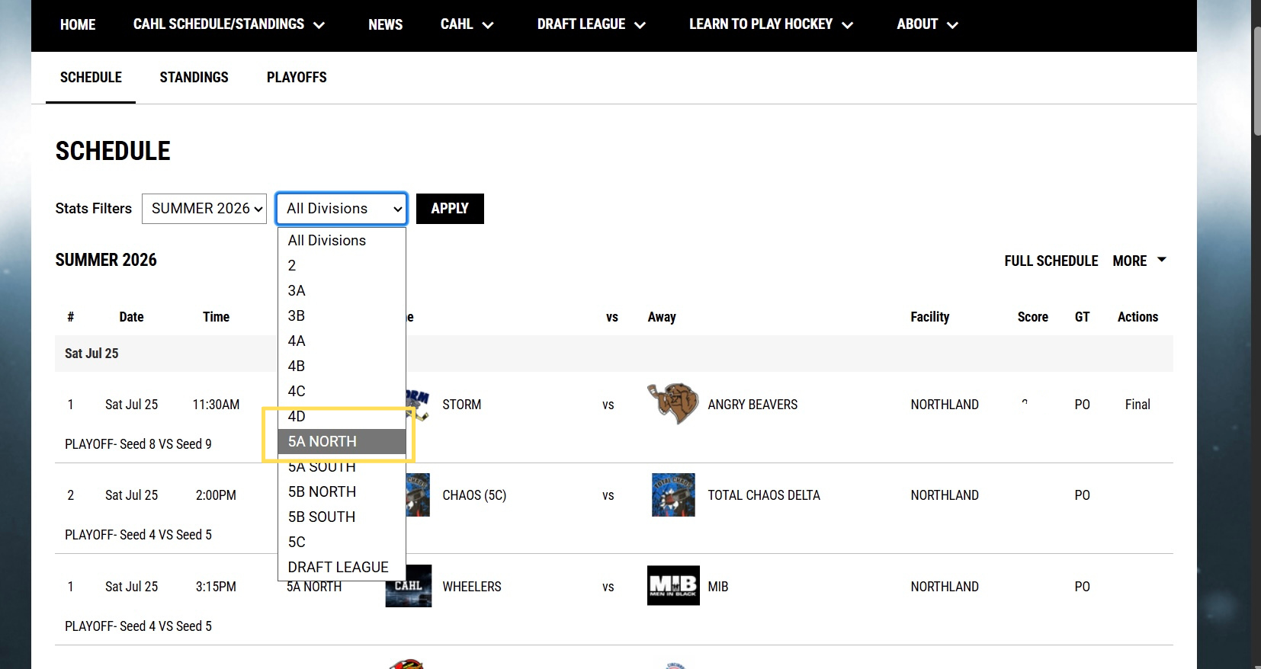
Select the division you want to access

