ACCESS PLAYOFF SCORES AND FUTURE SCHEDULE
** YOU MUST SWITCH TO FULL SCHEDULE TO VIEW ENTIRE PLAYOFF SCHEDULE! PAST GAMES WON’T SHOW IN CURRENT

FOR DESKTOP:
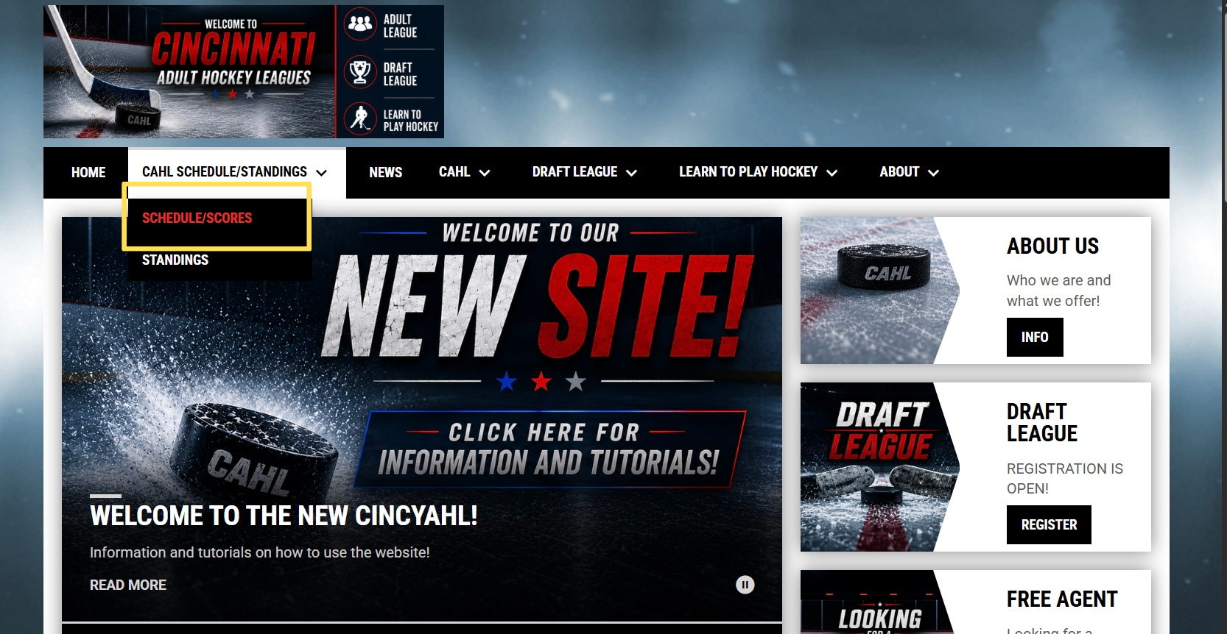
Click CAHL SCHEDULE/STANDINGS
Click SCHEDULE/STANDINGS
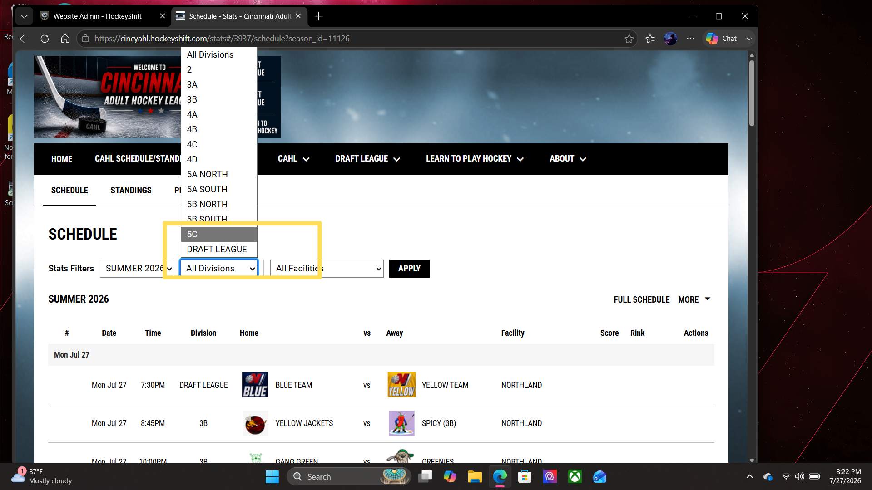
Select the division you want to access
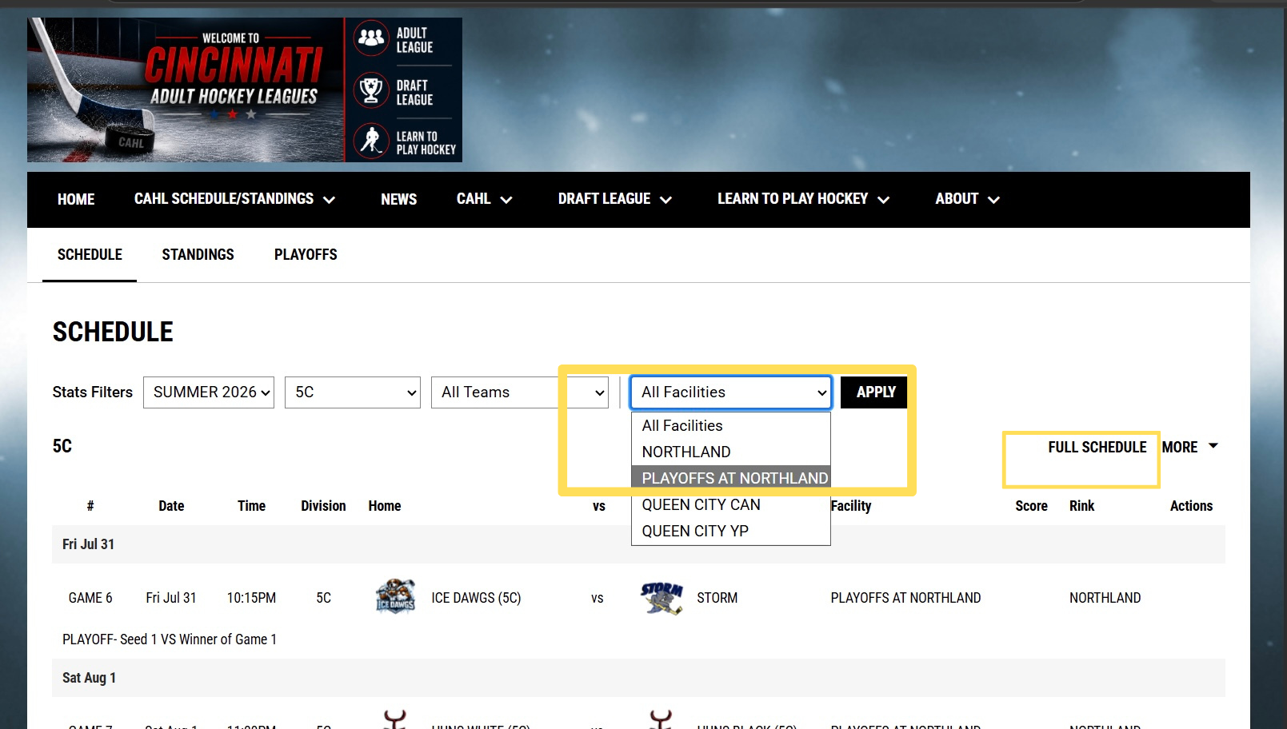
Select in facilities PLAYOFFS AT NORTHLAND and click APPLY
*** CURRENT SCHEDULE will load. Click FULL SCHEDULE on the right
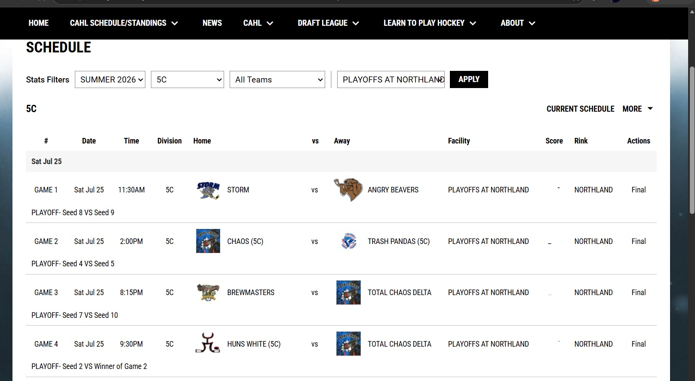
Playoff games will be fully listed with labels “GAME 1… GAME 2…”

FOR MOBILE:
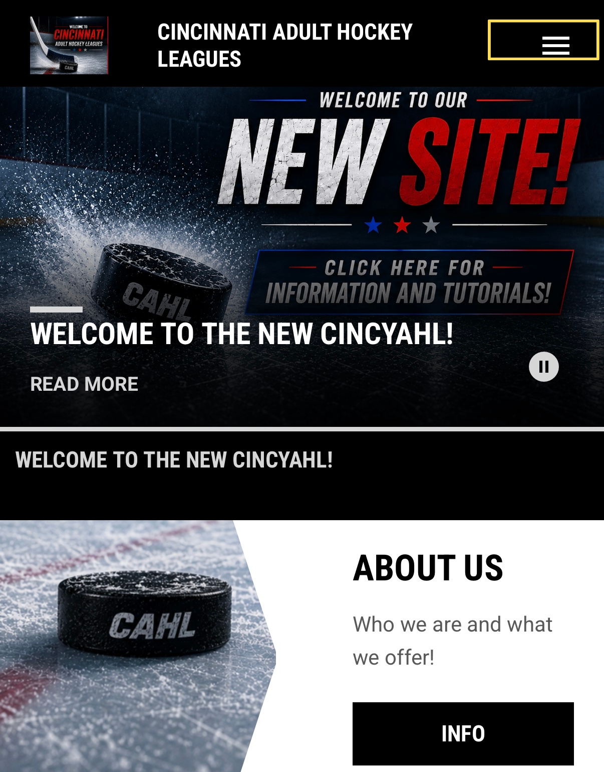
Click the 3 bars on the top right
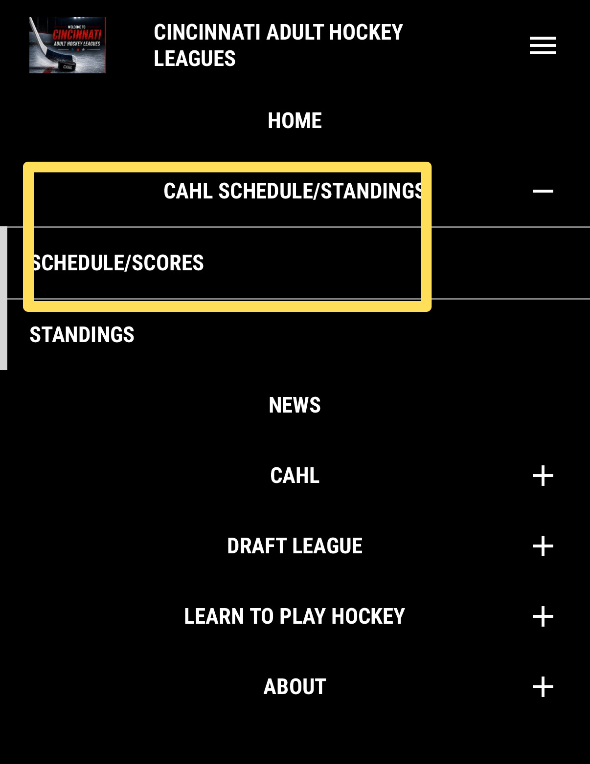
Click CAHL SCHEDULE/STANDINGS
Click SCHEDULE/SCORES

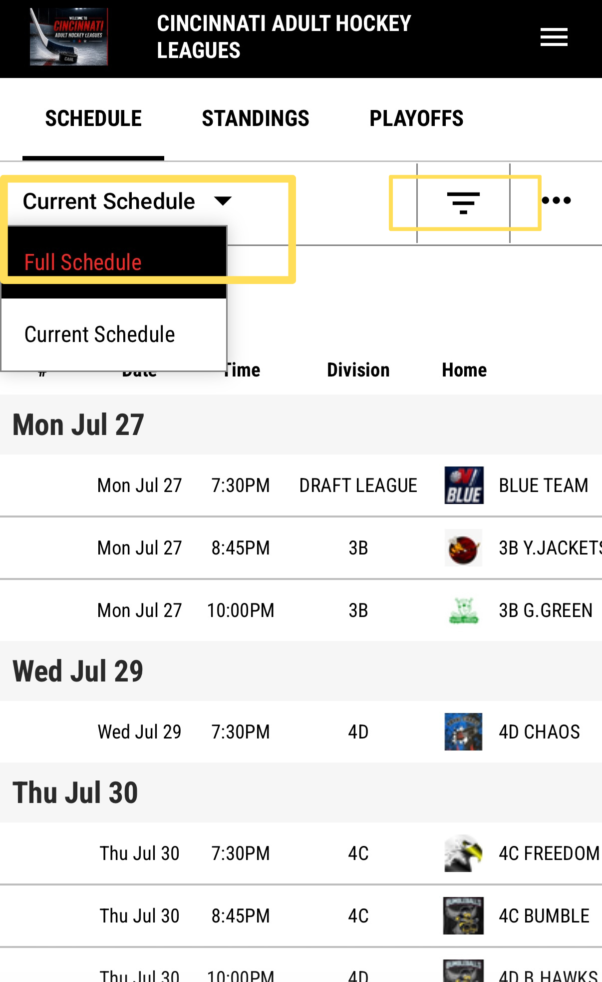
Under CURRENT SCHEDULE select FULL SCHEDULE
Then click the 3 bars to the right of it
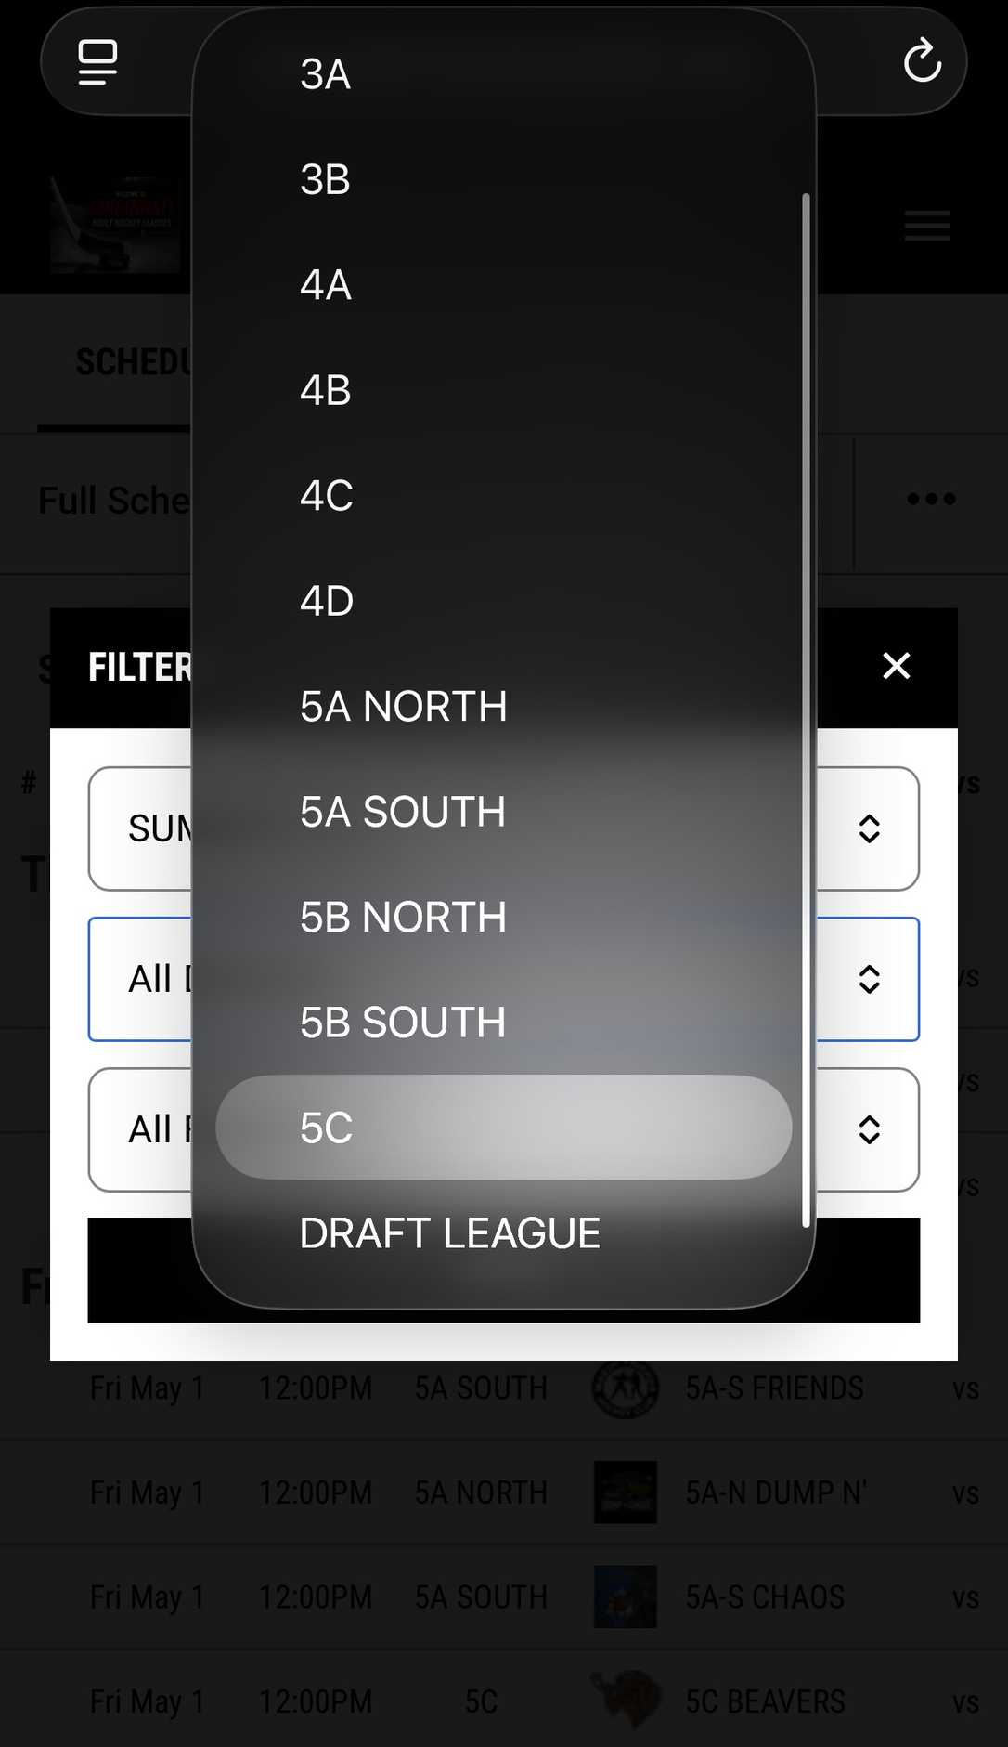
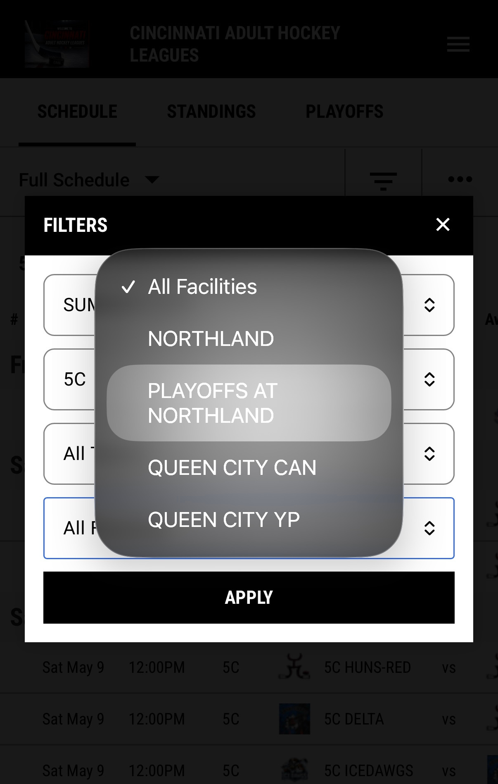
Under division select the division you want to access.
Under facilities select PLAYOFFS AT NORTHLAND
Click apply
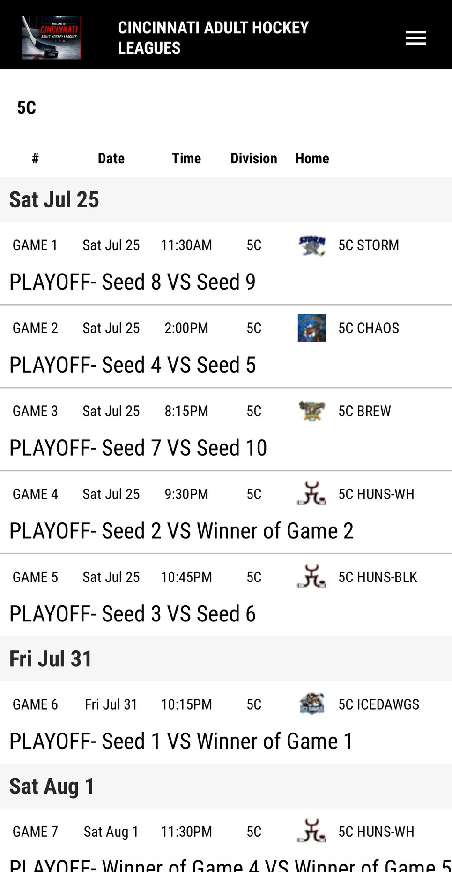
You can scroll to the side to see more.

