ACCESS CURRENT AND FULL SCHEDULE
** CURRENT SCHEDULE WILL AUTOMATICALLY LOAD- THIS IS YOUR REMAINING GAMES.
** FULL SCHEDULE WILL SHOW YOUR ENTIRE SEASON’S PAST GAMES

FOR DESKTOP:
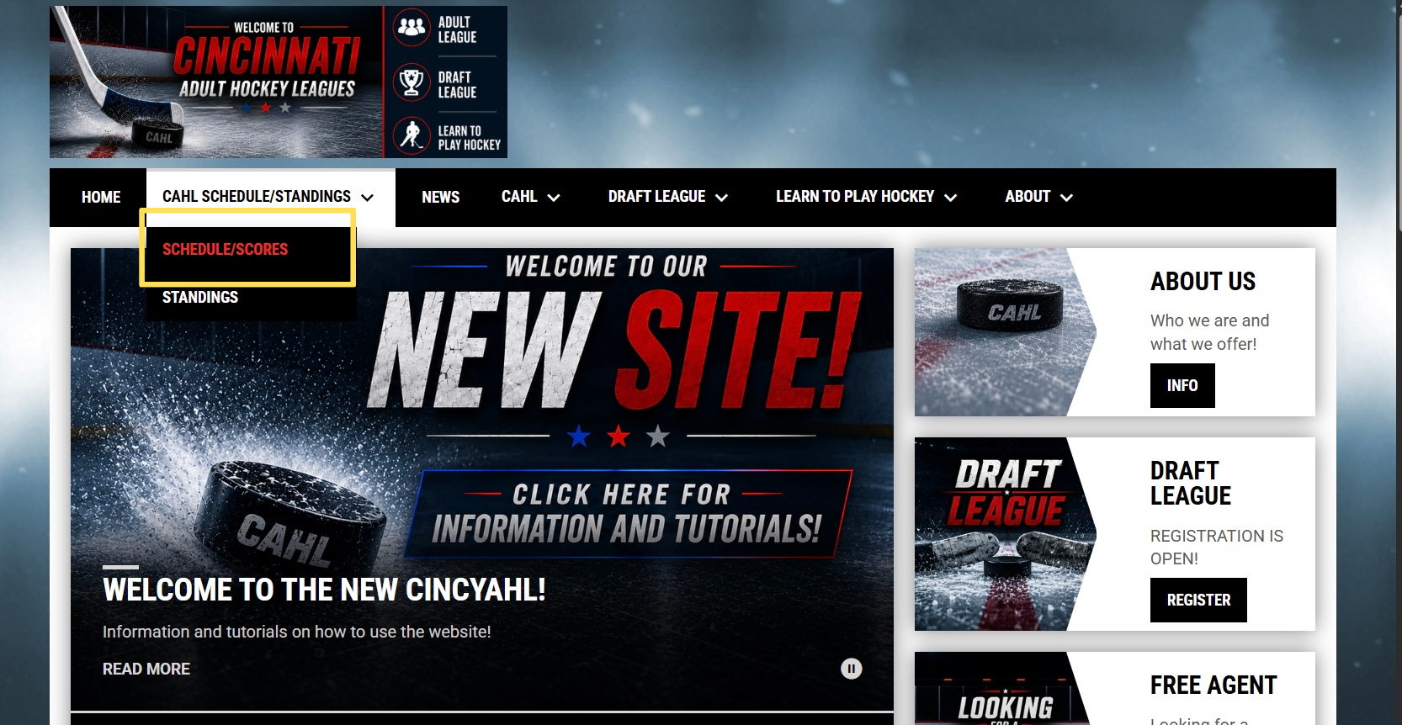
Click CAHL SCHEDULE/STANDINGS
Click SCHEDULE/SCORES
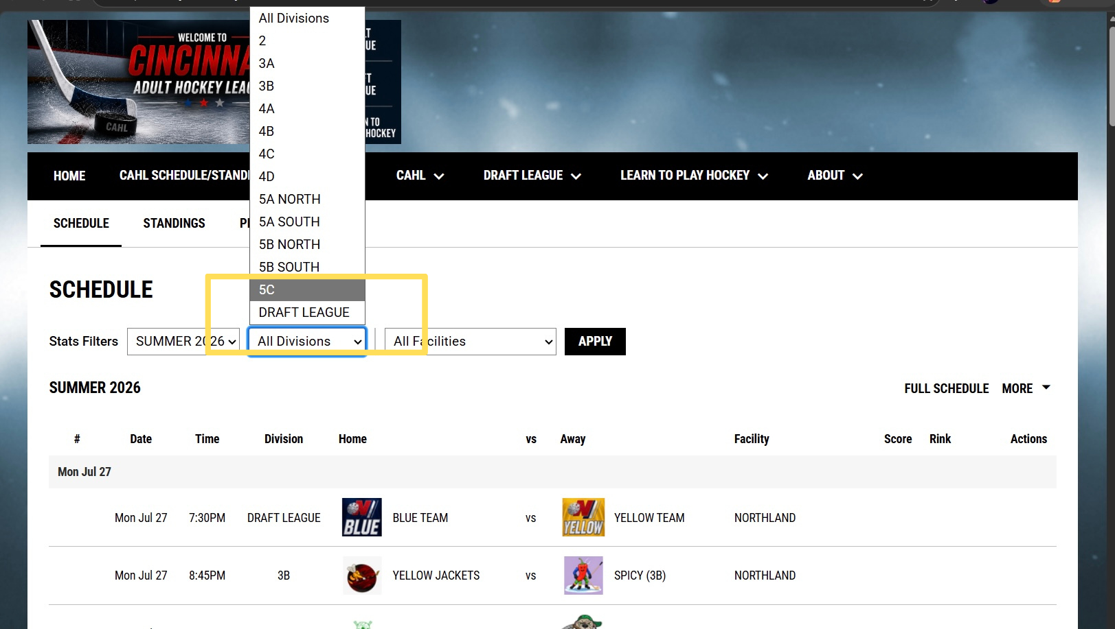
Select the division you want to access

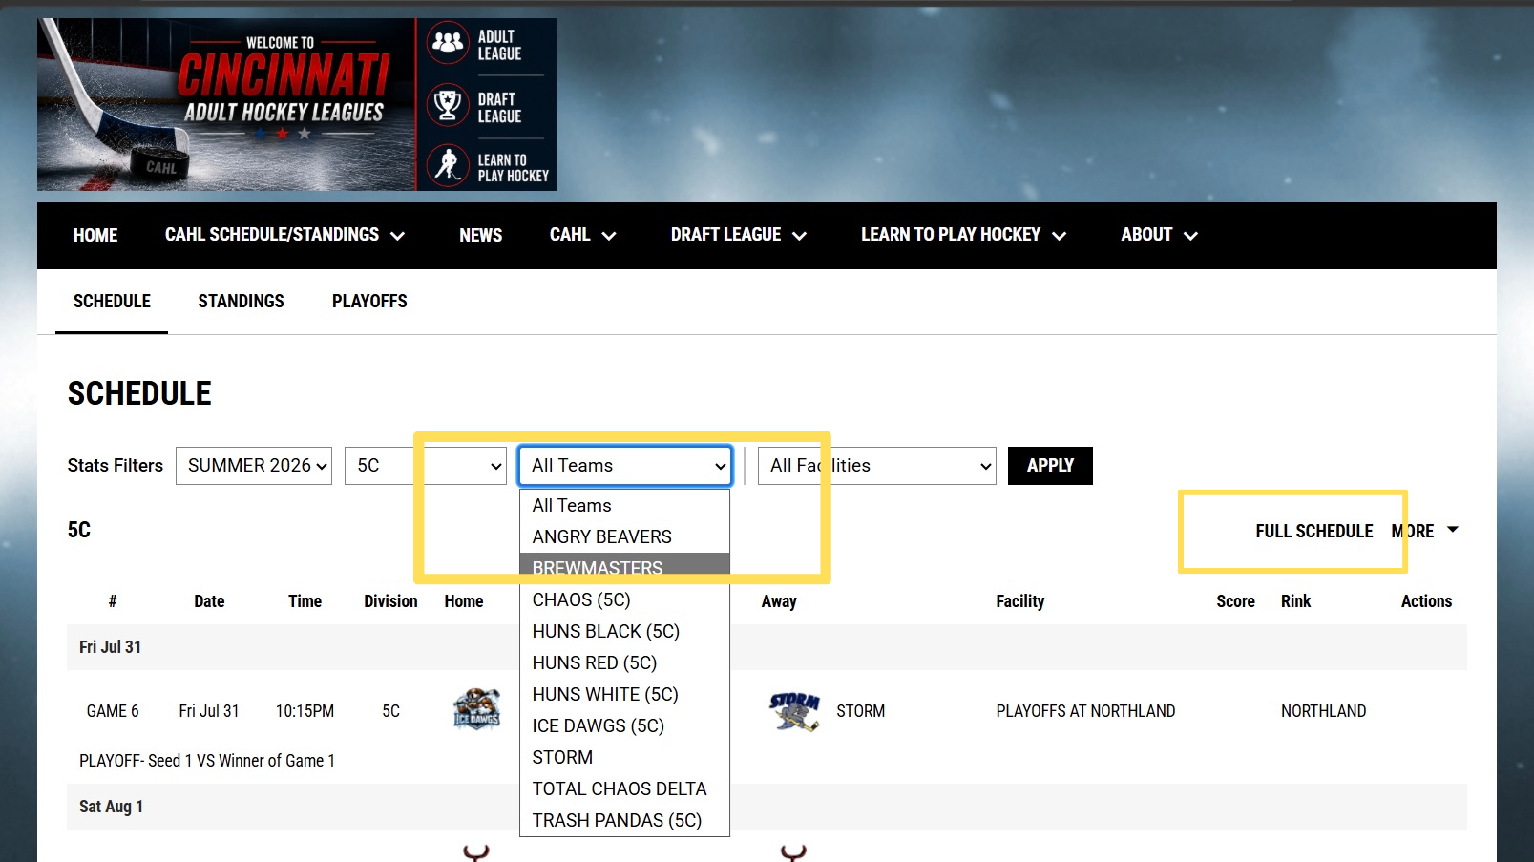
Select the team you want to access

*** CURRENT SCHEDULE will load. Click FULL SCHEDULE on the right if you want past games

FOR MOBILE:
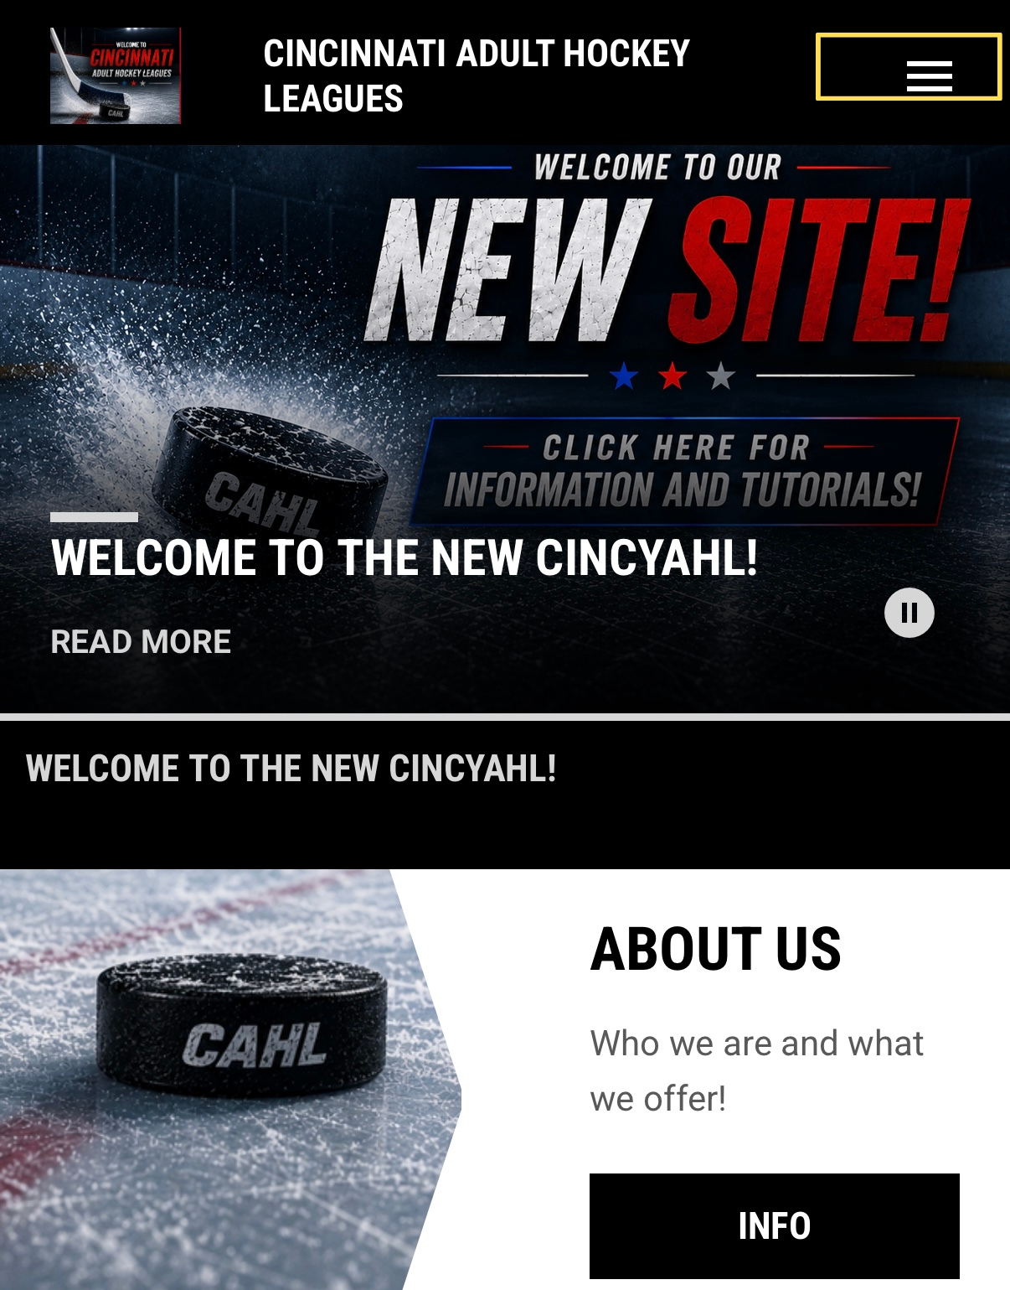
Click the 3 bars on the top right
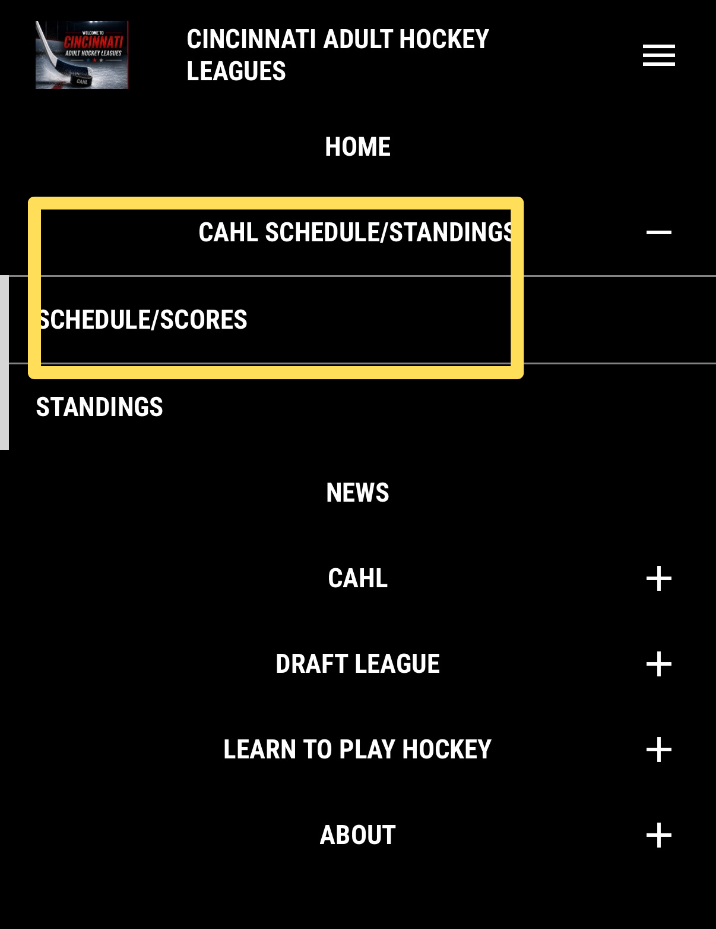
Click CAHL SCHEDULE/STANDINGS
Click SCHEDULE/SCORES

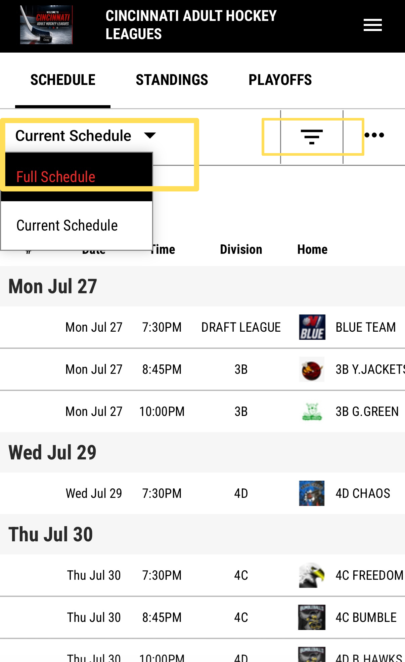
CURRENT SCHEDULE will load. Select FULL SCHEDULE if you want to see past games
Click the 3 bars to the right of it
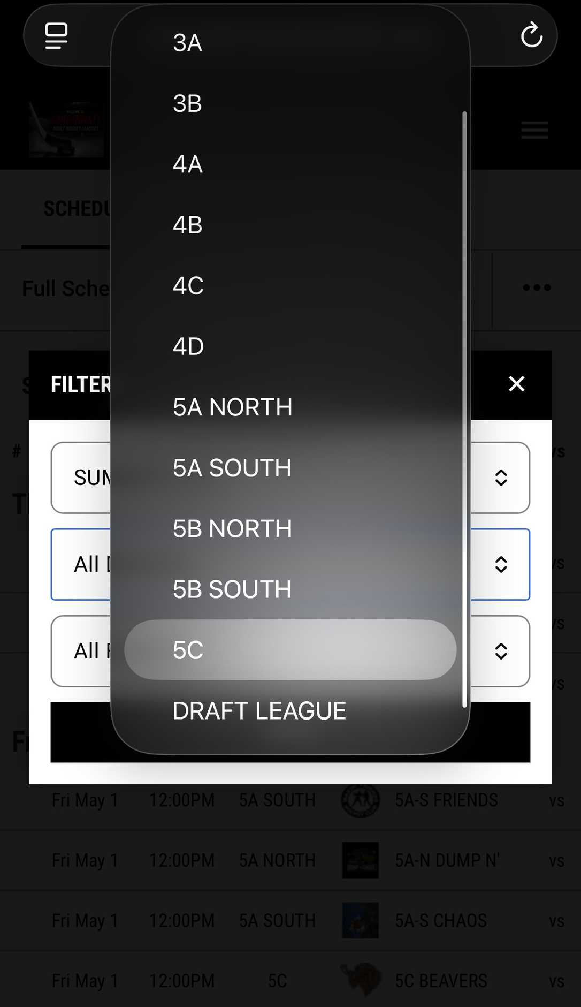
Under division select the division you want to access.
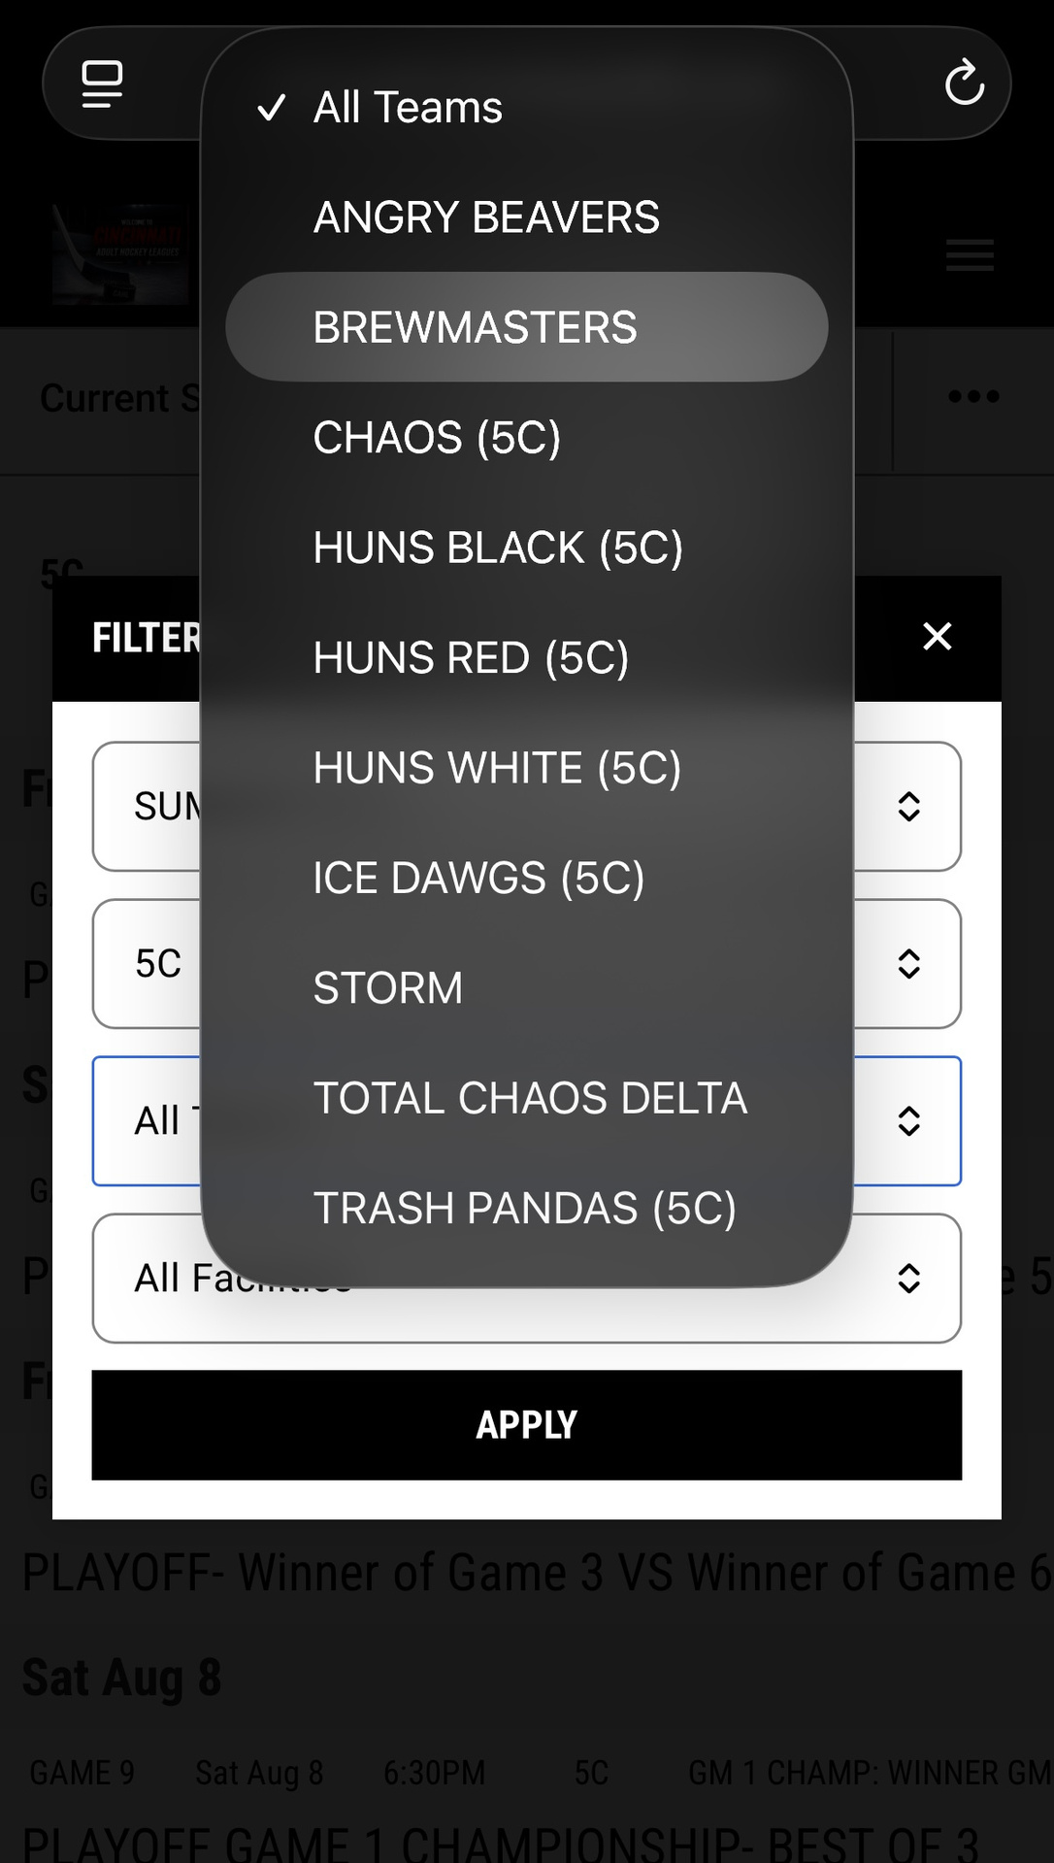
Select the team you want to access
Click apply

