ACCESS PLAYOFF SCORES AND FUTURE SCHEDULE
** YOU MUST SWITCH TO FULL SEASON TO VIEW ENTIRE PLAYOFF SCHEDULE! PAST GAMES WON’T SHOW IN CURRENT
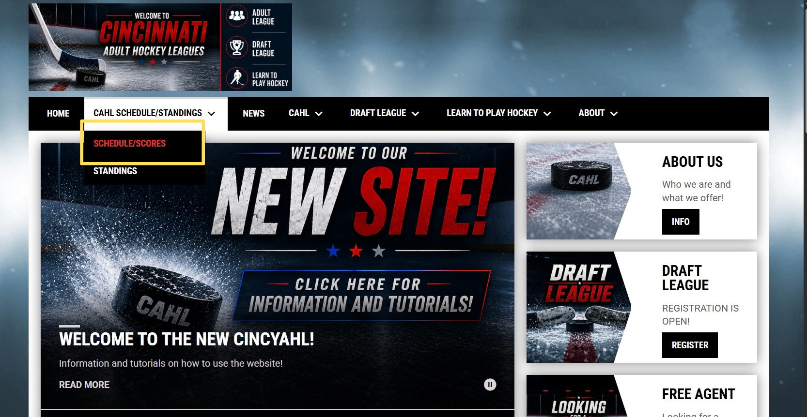
Click CAHL SCHEDULE/STANDINGS
Click SCHEDULE/STANDINGS
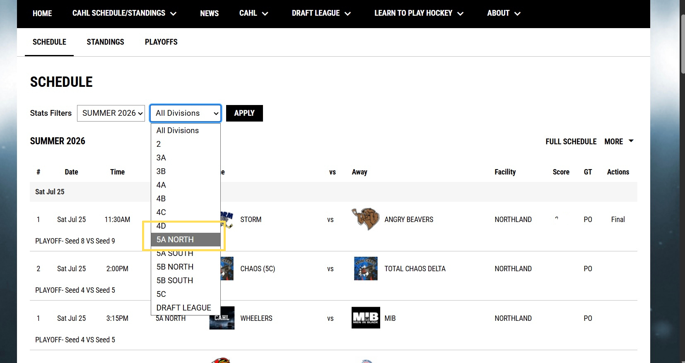
Select the division you want to access
*** CURRENT SCHEDULE will load
Click FULL SCHEDULE and scroll down
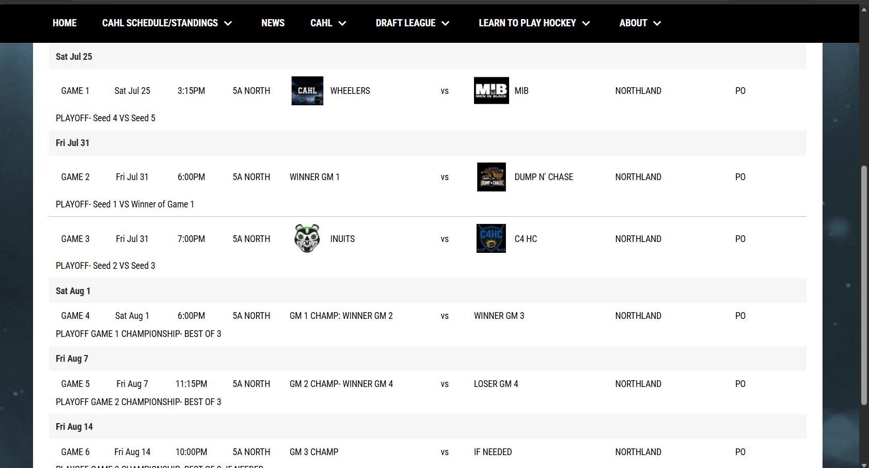
Playoff games will be fully listed at the bottom

