LYNBROOK ROLLER HOCKEY LEAGUE, INC.
GREIS MEMORIAL PARK, LYNBROOK, NY 11563
(516) 946-0528

E-mail us at: LYNBROOKROLLERHOCKEY@gmail.com
FALL 2025 Registration Form

Last Name_____________________ First Name________________________
Address:____________________________ Town:__________________Zip:_______
Parent/Guardian Cell#______________________ Cell#__________________________

Birth Date____/_____/_____ School___________________________ Grade_____

New player ?_____Returning ? _____# yrs experience: _______Ice player ?________

Mom/Guardian name: ____________________Dad/Guardian name: ________________

E-mail address: ____________________ E-mail address: _______________________
□ I would like to receive marketing and other emails from the New York Islanders and UBS Arena about youth programs, ticket offers, and more. By saying YES, you expressly agree to receive recurring automated promotional, personalized marketing, and non-promotional text messages.
PLEASE GET INVOLVED. THE FUTURE OF THE LEAGUE DEPENDS ON IT:

Coach Assistant Coach Snack Shack Fundraiser Anything

WAIVER AND RELEASE OF LIABILITY
In consideration for being accepted to participate in the Lynbrook Roller Hockey League, Inc., the undersigned Parent/Guardian of the roller hockey participant and the roller hockey participant:
Represent that the roller hockey participant is in good health and condition; and that they are not aware of any illness, physical condition, or injury, which would affect the roller hockey participant from
engaging in strenuous on-rink or off-rink physical activity.
Agree, acknowledges and fully understand that the roller hockey participant will be engaged in the sport of roller hockey and other strenuous physical activities that involve the risk of serious injury including permanent disability or death; the undersigned further agrees to assume all foregoing risks and accept personal responsibility for any and all damages follows any such injury, permanent disability, or death.
Agree that the roller hockey participant is personally responsible to wear full protective equipment during all games, warm ups and practices, and if the roller hockey participant observes any unsafe or dangerous condition, the roller hockey participant shall refuse to participate and immediately notify a roller hockey supervisor or one of the coaches of the league of the unsafe or dangerous condition Participants are responsible to report all accidents immediately to the league at the time of occurrence.
Release, waive, discharge and covenant not to sue Lynbrook Roller Hockey League, and it's respective
Administrators, directors, agents, supervisors, coaches, counselors, referees and other employees of
The corporation, other participants, sponsors, advertiser, and the owners, lessors, and/or lessee of any
Of the premises used to conduct the activities of the roller hockey league (all hereafter collectively
referred to as Releases), from any and all claims, demands, losses or damages on account of injury,
including permanent disability or death or damage to property, caused or alleged to be caused in
whole or in part by the negligent conduct of the releases or otherwise.

WE HAVE CAREFULLY READ THE FOREGOING WAIVER & RELEASE, SIGN IT FREELY,& VOLUNTARILY, AND ACKNOWLEDGE THAT WE ARE WAIVING SUBSTANTIAL RIGHTS.

______________________________
Parent/Guardian Signature
for league use only

DATE RECV’D___________ AMOUNT PAID:_________CHECK #___________CASH
DIVISION: _______EVALUATION DATE: _________RATED:_________RATED BY___________
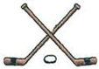 LYNBROOK ROLLER HOCKEY

CHECK OUT OUR FALL ’25 REGISTRATION DATES:
On Instagram lynbrook_hockey
On Facebook Lynbrook Roller Hockey
or our website www.lynbrookhockey.com

DIVISIONS FOR THE FALL 2024 SEASON
Clinic Kids: Born after 1/1/2019 (all ages welcome!)
Squirts: 1/1/2017 to 12/31/2019 (6-8)
Pee Wees: 1/1/2014 to 12/31/2016 (9-11)
Midgets: 1/1/2011 to 12/31/2013 (12-14)
Intermediates: 1/1/2007 to 12/31/2010 (15-18)
VILLAGE OF LYNBROOK RESIDENTS: $215.00
NON- LYNBROOK RESIDENTS: $250.00
BEGINNERS CLINIC – 10 SESSIONS $150.00
FULL EQUIPMENT SPECIAL FOR
NEW SQUIRT AGE SKATERS ONLY FOR $250.00
PRICE INCLUDES A FULL SET OF EQUIPMENT FOR
YOUR SKATER AND INCLUDES FALL REGISTRATION FEE!
VISIT OUR WEBSITE, FACEBOOK OR INSTAGRAM PAGES
FOR FURTHER INFORMATION…

FALL SEASON IS A 10 GAME SCHEDULE + PLAYOFFS
REGISTRATION FEE INCLUDES GAME JERSEY
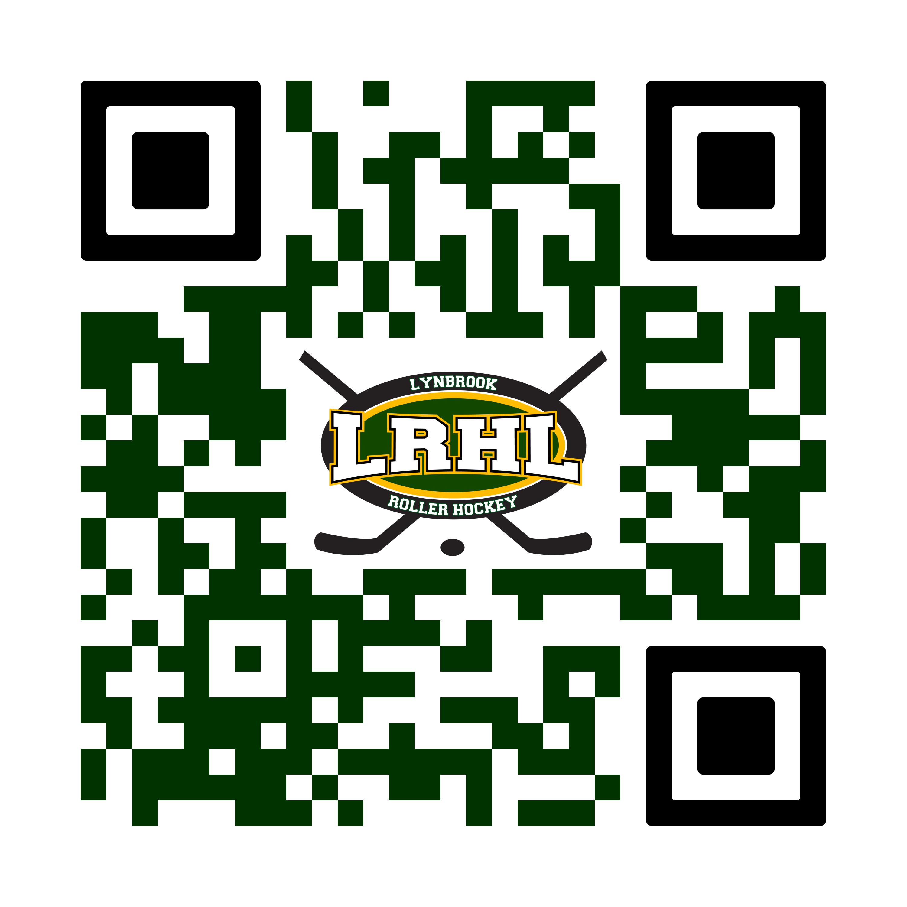
- LRHL reserves the right to place any skater into a division,
regardless of age, that best suits that skater’s talent level while keeping competitive balance throughout ALL league divisions.

