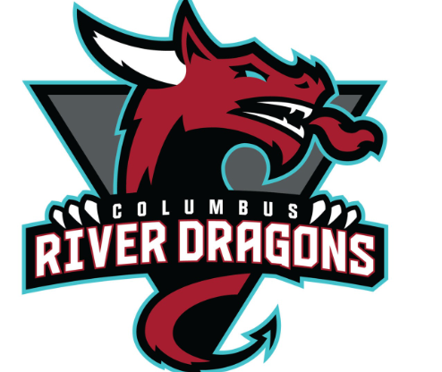

Ignite Sports & Entertainment

Black History Month
Featuring River Dragon’s Player #19 Thomas Aldworth
by Kamerion Lindsey on February 20th 2023
I had a sit down Interview with River Dragon’s Player #19 Thomas Aldworth as a tribute to Black History Month, him as an African American, Hockey player, and him as a person overall. I started off by asking Thomas, what does it mean being a young African American Man that's a part of the Columbus River Dragon’s Organization ? Thomas' overall answer was that it’s really nice playing in front of a large African American Fan Base here in Columbus, GA, that always shows up to our home games. Now I wanted to know What did Thomas think of Black History month, what comes to his mind right away about this historic month ?, and he mentioned some of the legends of the past like Martin Luther King, Rosa Parks, Harriet Tubman and Malcolm X. Now after Thomas told me some legends he grew up learning about, I went on to ask who are his top 3 historical black figures he admires the most in history and he lists Willie O’Ree, MLK, and Malcolm X. Then I would go on to ask Thomas what would he say to any young black child who wants to be a pro hockey player like him, he says to me that make sure to go out and have fun, it doesn’t matter if they next guy in the locker room looks like you or not just go out and have fun. Lastly I asked Thomas How does he celebrate black history month ?, Thomas usually likes to go back to his hometown area of Memphis/Brownsville, Tennessee to celebrate Black History month with his family.

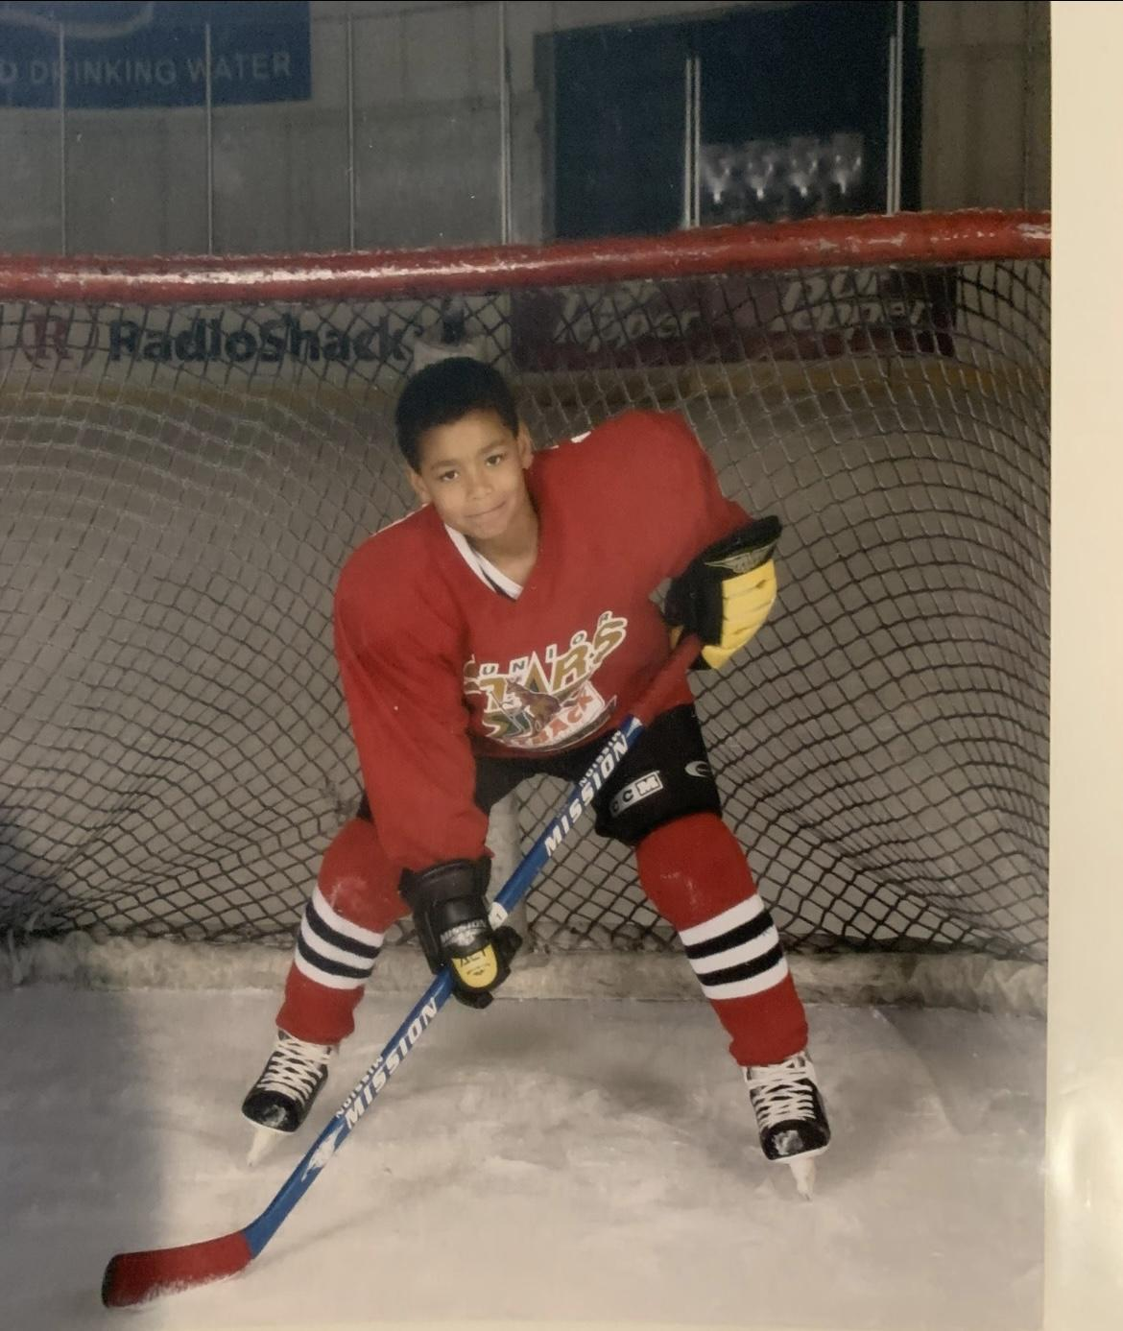

Where it all began for Thomas !!!
We all know that Thomas Aldworth is an incredible Player but what got him into hockey that made him into the superstar he is today?. That’s why I asked Thomas what made him get into the sport of hockey during his childhood or teenage years growing up ? He mentions living in Memphis and then moving to California where he started watching and playing street hockey just for fun with the neighborhood kids or teenagers. Then when he was 9 years old his family moved to Texas and he ended up living just a couple blocks away from the NHL team the Dallas Stars practice facility. Now Thomas mentions he and his dad never have seen ice hockey or ever watched or heard of the NHL and Dallas Stars, so he and his dad went to go check out the practice facility just cause they were curious. A security guard ended up stopping Thomas and his dad but once he told the man that they didn’t know what ice hockey was or a NHL professional team he let them in for a bit to watch the team practice and from then on end Thomas fell in love with the sport of hockey.

Who is Thomas Aldworth Outside of Hockey ?
Outside of the Ice rink and Columbus River Dragon’s Thomas is more of a homebody type of person, where he likes to play video games just a little, he plays with his two cats and enjoys watching tv shows with his girlfriend Emily. Also likes to hang out sometimes with his fellow River Dragons teammates whenever he finds time because he considers his teammates and River Dragons Organization his second family outside of his family back in Memphis and England.

( Clink Link for full Interview with Thomas Aldworth down below)

Kamerion’s Sports Podcast - YouTube

Ignite Sports & Entertainment

400 4th St, Columbus,GA 31901

