Board of Directors

August 6th, 2026

7:00pm
In-Person
Type of Meeting: Board of Directors
- Call to order -
- Roll call - Dan, Jim, Anthony, Jay, Joe, Bart, Justin
- Approval of minutes from last meeting [Meeting Minutes]: Kaiser motions to approve / Jay seconds - PASSES
- Adult Update:
a. Summer League: Heading into playoffs next week for both divisions.
b. Fall Registration: A and C are closed. B has 15 skater spots left.
c. 2 Sponsor positions left to fill.
- Youth Update:
a. Fall Season: $100 per season.
Potentially raise it up in the spring to $120.
b. Kaiser to Step Down at End of Year: His referral for the position is Corey Jackson.
-Kaiser has been giving Corey responsibilities over the last year to see if he could handle the responsibilities. Kaiser would want to have Corey co-commissioner the Fall Season.
-Dan said that even with the history from the previous time Corey has served on the board that he has matured and has been a positive person in the youth league. Dan would even recommend that if the board was to choose Corey as the next commissioner that he would join the board to fill the unfilled position.
-Anthony would like to have a meeting with Corey as a board to discuss him potentially transitioning into the full time Youth Commissioner. This does not have to be the full board. It can be the executive committee.
-Dan will contact Corey to set up a date to meet and discuss his vision on youth.
- Financial Update: (See Below)
a. Financials:
- Account 1: $109,018
- Account 2: $65,430
- New Business:
a. Board Attendance Policy: We have a policy about attendance at meetings. We have had to reschedule a couple meetings where we needed to reschedule due to not having a quorum. We just want members to be committed and attend each monthly meeting and understand if something comes up and you cannot attend.
b. Board Member Participation: We would want board members to bring more to the league and be more active. This could be in physically helping on repairs, youth, or fundraising. If none of these fit, we need to find something that a board member can do to benefit the league.
c. Warehouse in Swannanoa: Jay motions that we pursue the indoor space. Jim seconds. Bart will type up an offer letter. PASS
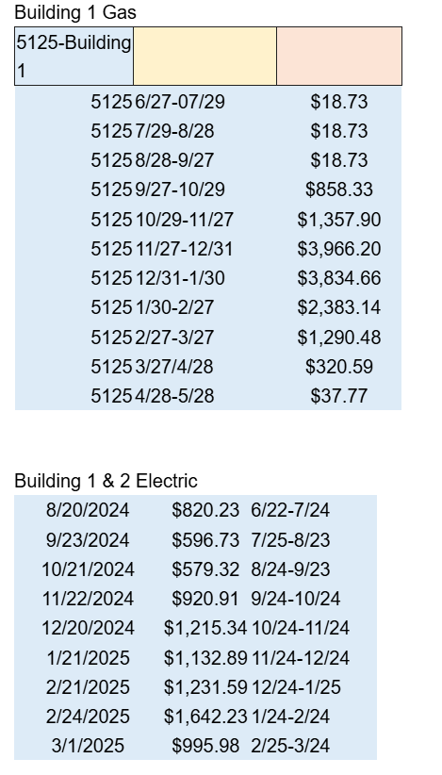
Indoor Rink
134 skaters x $200 = $26,800
3 seasons: 80,400
4 seasons: 107,200
160 skaters x $200 = $32,000
3 seasons: $96,000
4 seasons: $128,000
134 skaters x $220 = $29,480
3 seasons: $88,440
4 seasons: $117,920
160 skaters x $220 = $35,200
3 seasons: $105,600
4 seasons: $140,800
Sunday Mix League? Like summer?
6-10 extra teams.
6 teams / 48 skaters @ $220 = $10,560
8 teams / 64 skaters @ $220 = $14,080
(Adds more ref/sk/commish costs)
$2 / sqft = $4,200 / month ($50,000)
$3 / sqft = $6,250 / month ($75,000)
$4 / sqft = $8,400 / month ($100k)
52 weeks / year
(weeks per season depend on number of teams and length of playoffs)
3 seasons is 17 weeks (once a week)
(12 games / 3 weeks playoffs) 6/8 teams
6 team ref/sk cost (16 teams): $8,720
8 team ref/sk cost (20 teams): $10,960
Needs Less Games (Priced Out)
4 seasons is 13 weeks
(10 games / 3 weeks playoffs) 6/8 teams
team ref/sk cost (16 teams): $7440
8 team ref/sk cost (20 teams): $9360
——————————————————————
Adult commish pay for 134 skaters = $1340
3 seasons: $4020
4 seasons: $5360
Adult commish pay for 160 skaters = $1600
3 seasons: $4800
4 seasons: $6400
Commish/sk/ref for 1 year: ~$30,180
Other ways to revenue stream:
Roller derby (50k set aside for something)
Pickup
Tournaments @ $$ per hour
Skate nights
Expenses:
~$45,000 for tile
Cleaning company for bathrooms twice/week
UTILITIES (heat in winter & lights at night)
SPONSORSHIPS AND FUNDRAISING IS CRUCIAL!!!!
- Old Business:
a. Hurricanes Boards: We will know soon whether or not their board will donate their ice boards to the league.
Next Meeting: September 3rd @ 7pm
Adjourn: Jay motions / Dan seconds 8:21pm
