

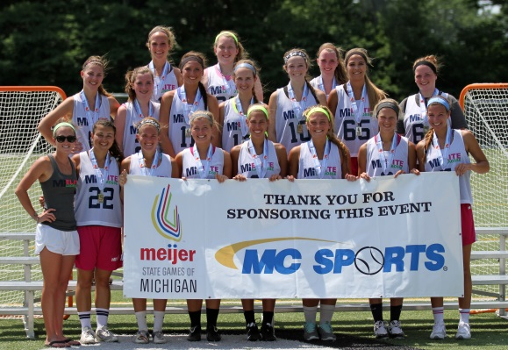MI Elite is a great opportunity for girls to improve their lacrosse skills in the off-season for a very reasonable price compared to other clubs in Michigan! MI Elite started in 2011 with one team as TeamLax and grew to six teams in 2014. This summer our goal is to have six teams; one 2021/2022 team, two 2019/2020 teams, one 2018 team, one mixed high school team, and one 2015 team. Rosters will have a cap of 20-22 girls per team in order to ensure adequate playing time for all players. Each team will practice twice a week, two hours per session, at Chippewa Middle School in Okemos. The MI Elite staff includes current college lacrosse players who help the girls improve their skills, knowledge of the game, and have fun! A $100 deposit made out to Mackenzie Lawler can be sent to her at 4466 Arbor Drive, Okemos, MI, 48864 to secure a spot on a team. Roster spots fill fast. Last year we had to turn players away, so don’t wait!

Feel free to email Coach Mackenzie Lawler at [mielitelacrosse@yahoo.com](mailto:mielitelacrosse@yahoo.com) with any questions. Additional information and registration can be found at our website at [www.mielitelacrosse.com](http://www.mielitelacrosse.com).

**STAFF**

|  |  |
| --- | --- |
|  | **Mackenzie Lawler**: Current assistant at Central Michigan University. Former starting midfielder at Division I Robert Morris University. Helped the colonials appear in the NEC Tournament in 2011 and lead the team in assists in 2012. This will be Mackenzie’s fifth year coaching Michigan Elite. Mackenzie is also a director and owner of the club. |
|  | **Jordan Luberto:** Current senior midfielder at Division II Grand Valley State University. In her sophomore season Jordan started 17 of 18 games where GVSU finished winning a GLIAC Championship. Jordan redshirted her junior season after tearing her ACL. This will be Jordan’s fourth year coaching Michigan Elite. Jordan is also a director and owner of the club. |
|  |  |
|  | **Allison Kelly:** Current sophomore midfielder at Division II University of Findlay. Allison played two years of varsity lacrosse in New Jersey and then two years at Brighton. She was a two-time All-State Honorable Mention player and two-time KLAA First Team selection. This will be Allison’s second year coaching with Michigan Elite. |

New staff for 2015 also includes…

* **Emma DeYoung:** Current freshmen midfielder/defender for Detroit Mercy from Grand Rapids.
* **Olivia Sherman:** Current freshmen attacker for University of Findlay from Okemos.
* **Kristina Scott:** Current freshmen midfielder for Indiana Tech University from Brighton.

**Goalie instruction will be provided**

**Teams & Tournament Schedules**

|  |  |
| --- | --- |
| **2021/2022 Grad Team: (cost-$350)**   * Great Lakes Lacrosse Invitational (Kalamazoo, MI) 7/10-7/12 * Midwest Lacrosse Challenge (Westfied, IN) 7/25- 7/26 | **2019/2020 Grad Teams: (cost-$450)**   * Meijer State Games (Grand Rapids, MI) 6/20 – 6/21 * Great Lakes Lacrosse Invitational (Kalamazoo, MI) 7/10-7/12 * Midwest Lacrosse Challenge (Westfied, IN) 7/25- 7/26 |
| **2018/2016/Mixed High School Teams: (cost- $550)**   * IWCLA Midwest Cup (West Chester Township, OH) 6/27-6/28 * Great Lakes Lacrosse Invitational (Kalamazoo, MI) 7/10-7/12 * Midwest Lacrosse Challenge (Westfied, IN) 7/25- 7/26 | **Uniforms are an additional $60**  **Teams will be rostered based on graduation year/skill level (each player will be evaluated by MI Elite staff)** |

MI Elite Authorization for Medical Treatment

Parent(s)/Guardian(s)

Address City State Zip

(H)_____________________ (C)______________________ ______________________________________________________

Home Phone Number Cell Phone Number Email Address(es)

________________________ _____________________________ ______________________________________________________

Medical/Health Insurance Co. & Policy No. Emergency contact / Relationship to player

_____________________________________________________ ______________________________________________________

Allergies/allergic reactions of child Medications being taken by child

Other information regarding my child’s health that a doctor should know

I am the parents or legal guardian(s) of the above named minor child. I understand that, in the event that medical treatment is required, every effort will be made to contact the above named parent/guardian. However, in the event that I cannot be reached, I give permission to provide the medical treatment necessary for my child’s well being. I accept full financial responsibility for said medical treatment.

____________________________________________________ _______________________________________________________

Parent/Guardian Signature Date